Quickomics Supplementary

Table of Contents

1 Introduction 3

2 Select Dataset 4

2.1 Sample Table 4

2.2 Project Overview 5

2.3 Result Table 5

2.4 Data Table 6

2.5 Protein Gene Names 6

2.6 Help 7

3 QC Plots 8

3.1 PCA Plot 8

3.2 Eigenvalues 11

3.3 PCA 3D Plot 12

3.4 PCA 3D Interactive 13

3.5 Sample-sample Distance 14

3.6 Dendrograms 14

3.7 Box Plot 15

3.8 CV Distribution 15

3.9 Order Groups 16

3.10 Help 17

4 Volcano Plot 18

4.1 Volcano Plot (Static) 18

4.2 Volcano Plot (Interactive) 20

4.3 DEGs in Two Comparisons 20

4.4 Data Table 22

5 Heat Map 23

5.1 Static Heatmap Layout 1 23

5.2 Static Heatmap Layout 2 24

6 Expression Plot 26

6.1 Browsing 26

6.2 Searched Expression Data 26

6.3 Data Table 27

6.4 Result Table 28

7 Gene Set Enrichment 30

7.1 Gene Set Enrichment 30

7.2 Gene Expression 31

7.3 Gene Set Heat Map 31

7.4 KEGG Pathway View 32

8 Pattern Clustering 33

8.1 Clustering of Centroid Profiles 33

8.2 Data Table 33

9 Correlation Network 34

9.1 visNetwork 34

9.2 Data Table 34

10 Venn Diagram 36

10.1 vennDiagram 36

10.2 VennDiagram(black & white) 36

10.3 Intersection Output 37

10.4 DEG Table 37

11 Venn Across Projects 38

11.1 vennDiagram 38

11.2 Intersection Output 38

12 Output 39

# Introduction

The Quickomics interface can be accessed via the url <http://quickomics.bxgenomics.com/>. It has been implemented through RShiny and helps with visualizing secondary and tertiary analysis for RNAseq and Proteomics datasets. This supplemental text will serve as a detailed guide on using the different functionalities and customizing the tools to best fit individual datasets.

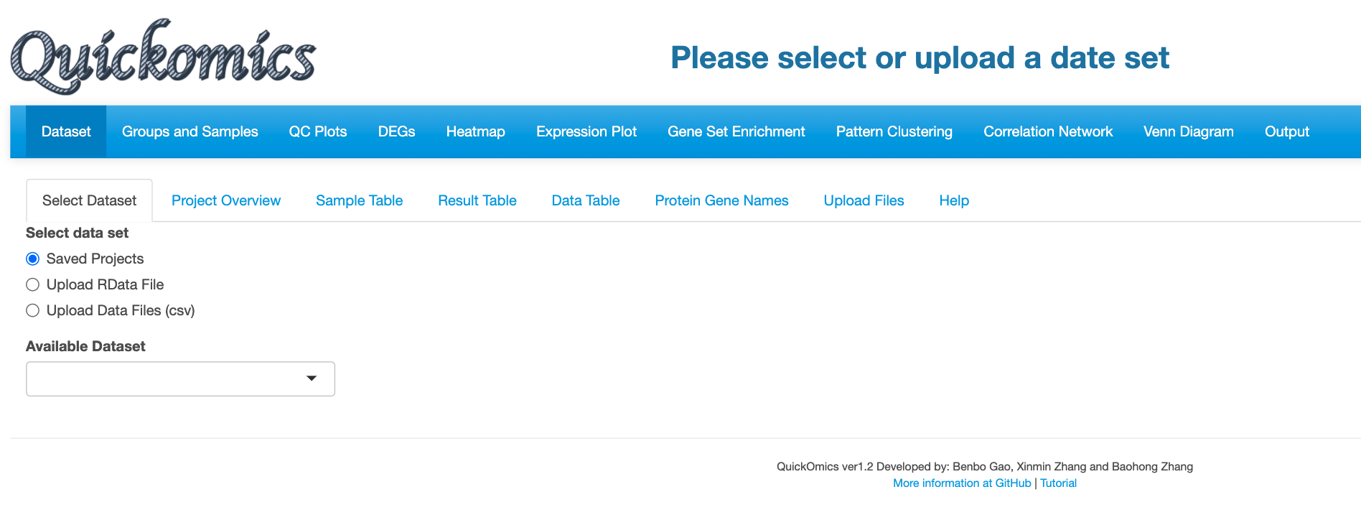

**Tabs for different functionalities**

The interface is split into multiple tabs, corresponding to different functional modules, that can be accessed right on top of the webpage. Users have the option to upload their own dataset or choose from existing datasets for visualization.

# Select Dataset

This is the first tab is for selecting datasets. Users can either select from pre-loaded datasets or upload their own dataset in a pre-defined format as detailed in our github page (<https://github.com/interactivereport/Quickomics>). We have added four pre-loaded datasets from published studies that Users can use for demonstrative purposes.

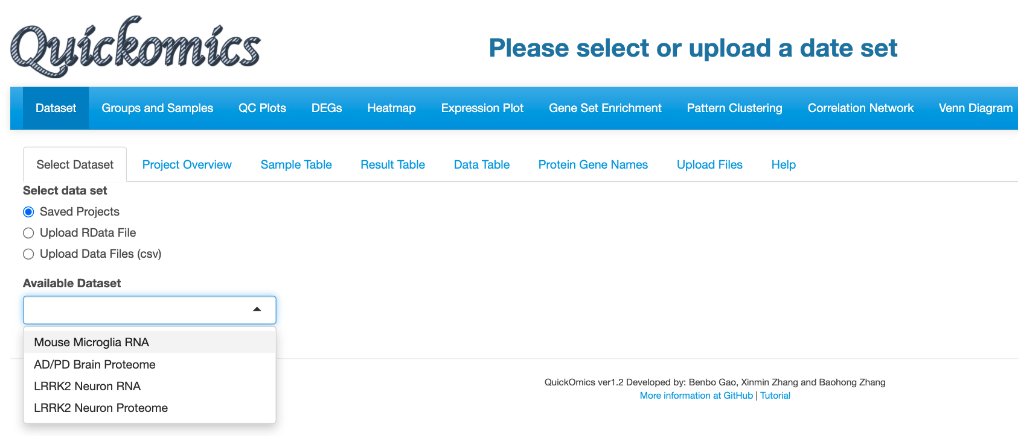

**Pick from pre-loaded datasets**

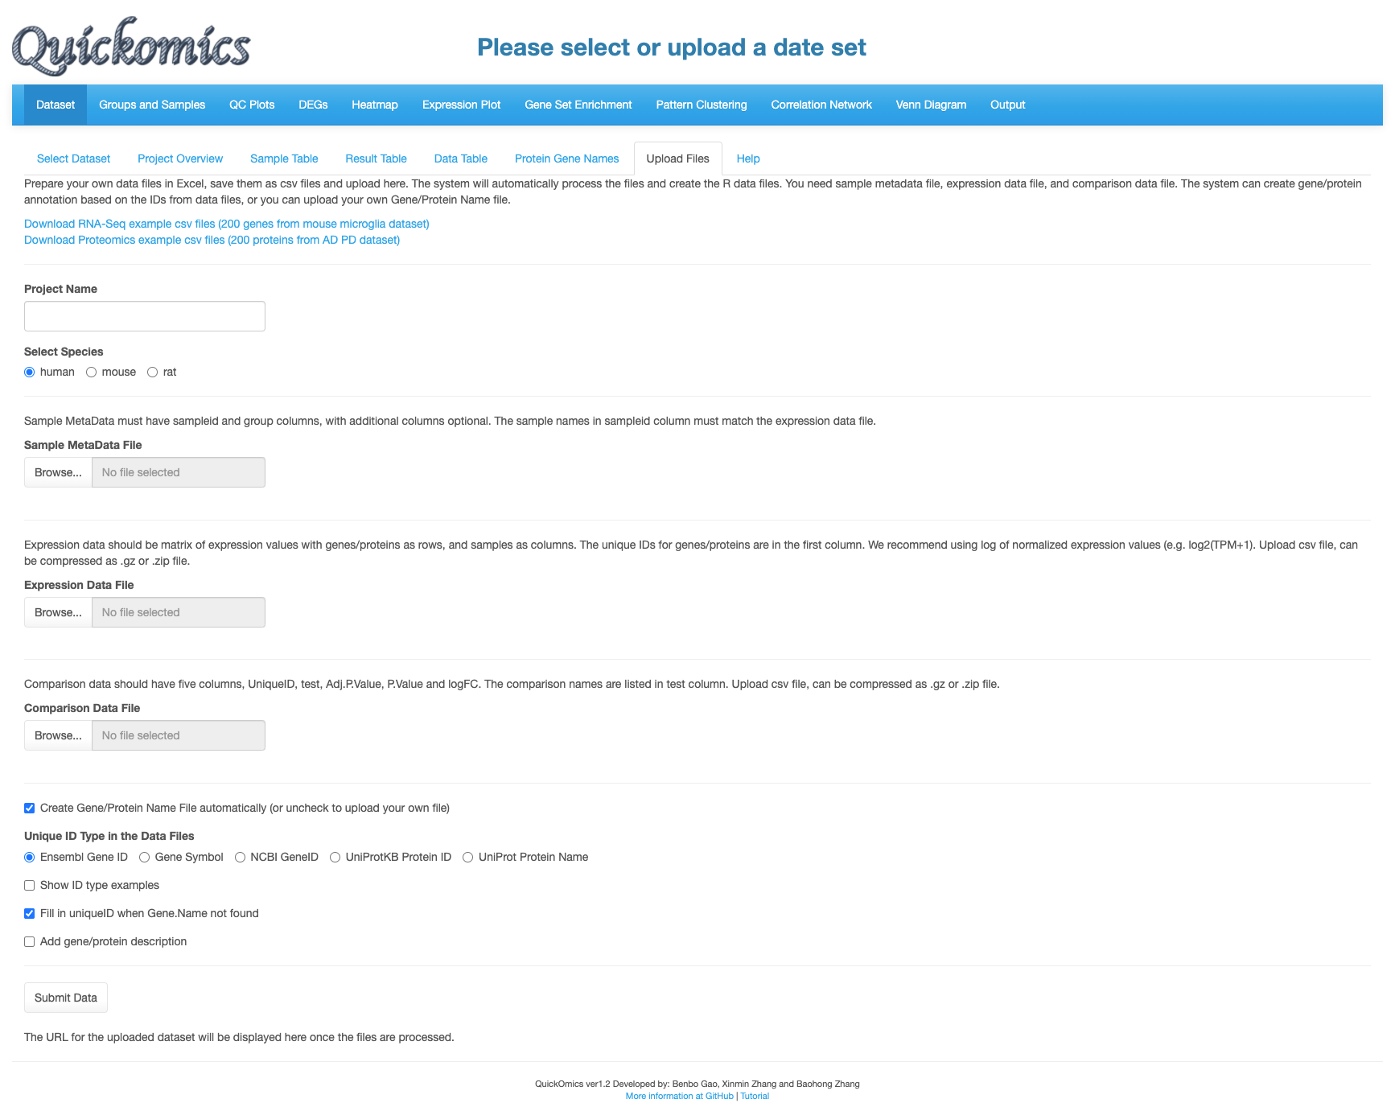

**Link will be generated to access the uploaded project**

**ID handling options**

**Upload files**

**Tool to upload text files directly**

## Sample Table

Once the dataset is selected the data on the right panel gets auto populated with metadata/details. Here we have selected the “Mouse Microglia RNA” dataset, previously published in Gyoneva et al., 2019 to illustrate all the functionalities.

The Sample Table contains details of all the samples that were sequenced. In this project there were 93 total samples with attributes like sampleid, group, Age, Genotype and Gender.

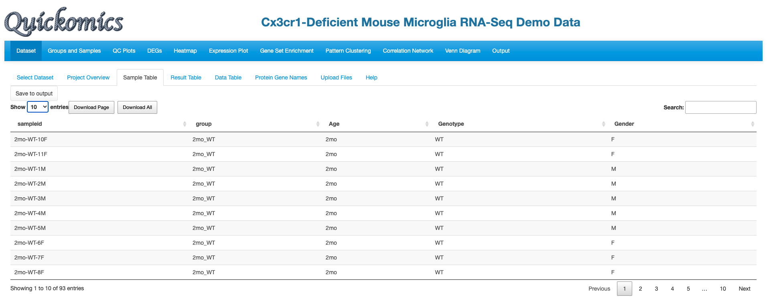

**Metadata attributes as columns**

**Showing the total number of samples**

## 

## Project Overview

This tab gives an overview of all samples in the project by providing a summary from the metadata. This includes information like which species was used, the different comparisons run and total number of samples in each group. This tab also helps identify how many groups were present in the dataset, for example in this project there are 9 different groups.

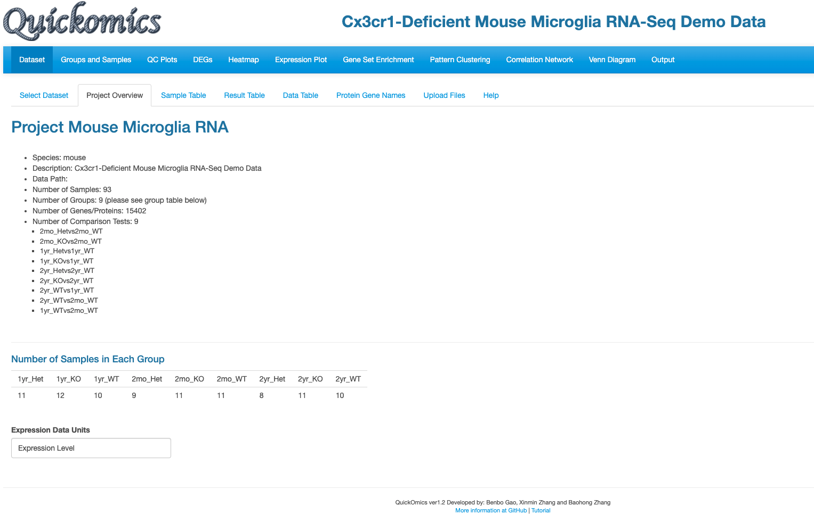

**Details about the project and listing the comparisons as defined during data upload**

**Quick summary of data structure in groups**

## Result Table

This tab contains the average normalized count values (TPM) per group for each gene. Each group has the mean normalized count value calculated from replicates of the group and a standard deviation value to denote the variation across the replicates.

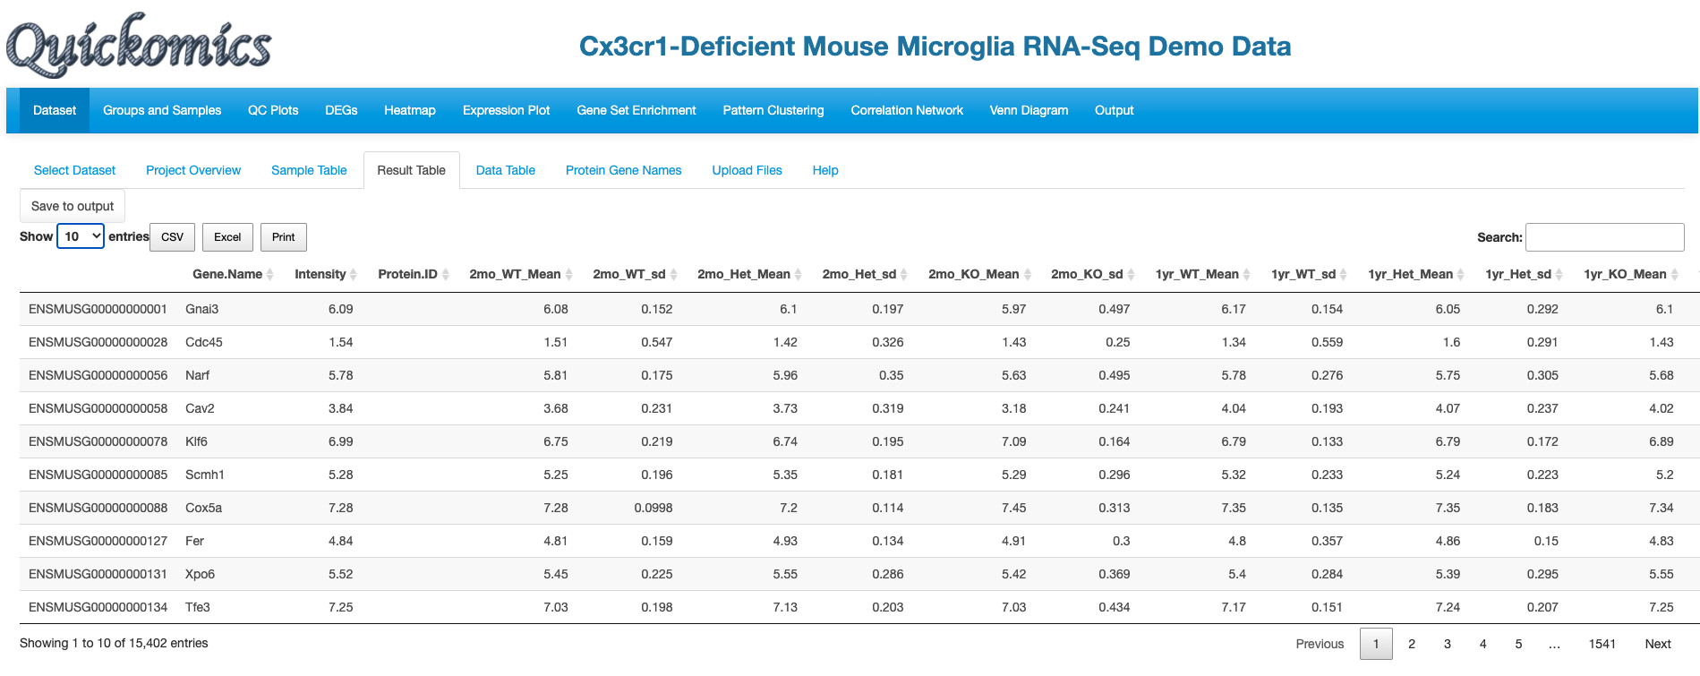

**Mean and SD per group**

## Data Table

The Data table on the other hand contains normalized expression values (TPM) per sample for each gene.

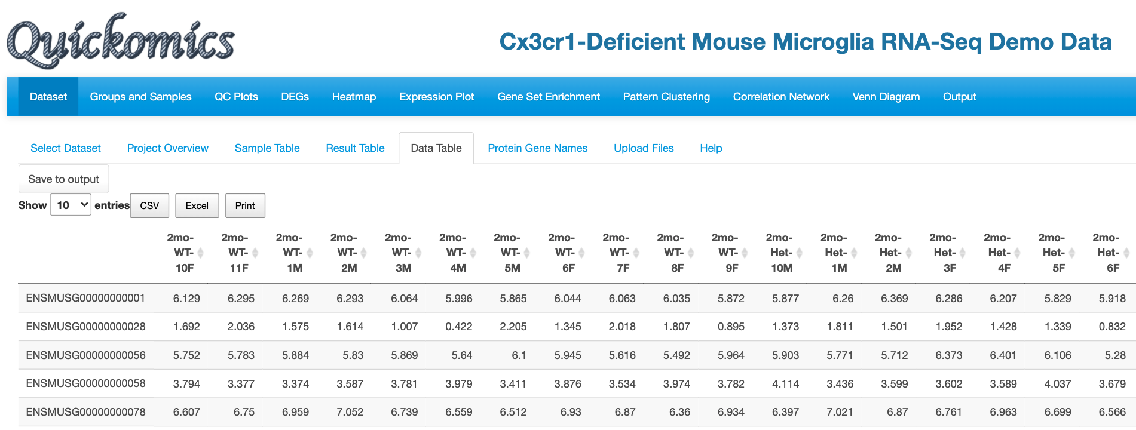

**Each row is one gene**

**Each column is one sample**

## Protein Gene Names

This tab contains details about each gene, and if a corresponding protein ID was associated with it in the experiment. Quickomics gives the ability to take in proteomics dataset and this is a useful feature to associate protein name with gene id.

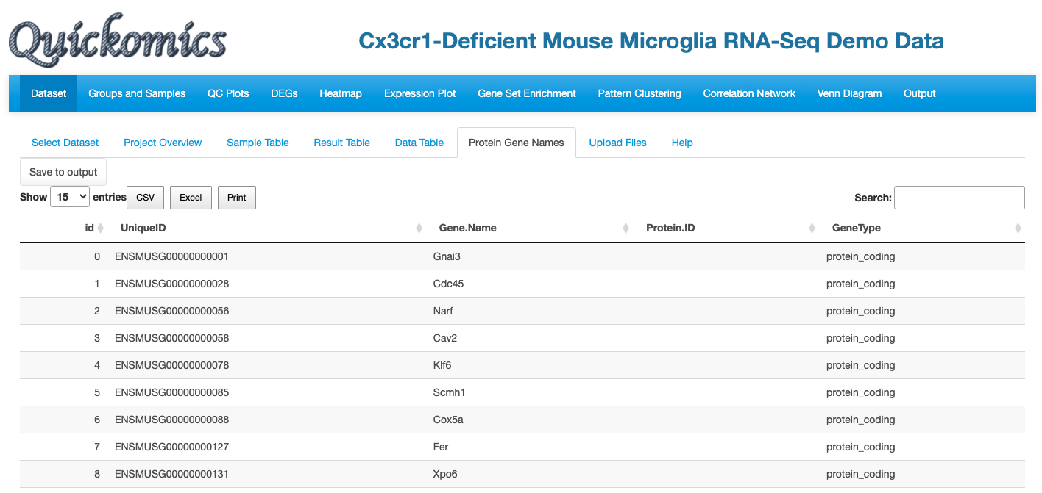

**For protein data, Protein.ID can be matched to Gene.Name**

## Help

Finally, the “Help” feature summarizes what data is being displayed in each tab under Select Dataset. The Help tab is available for all sections of the subsequent analysis.

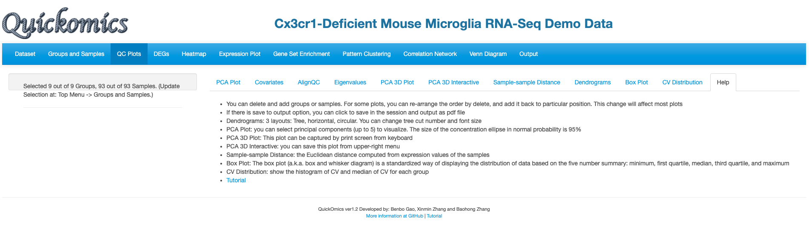

**Click here for further questions**

# QC Plots

For every dataset, the first step of the analysis is to perform basic QC and test the integrity of the data. ”QC Plots” tab performs basic QC analysis on the datasets and helps produce high quality figures. The plots were generated using ggplot2, plotly, ComplexHeatmap and pheatmap R packages **(Add reference).**

## PCA Plot

The principle component analysis (PCA) plot displays by default the first 2 PC’s in the dataset. The default settings for display are to color by the group with no shape or size selected. This plot is highly customizable: depending on the project and samples, different attributes can be highlighted.

**Name of the dataset being probed**

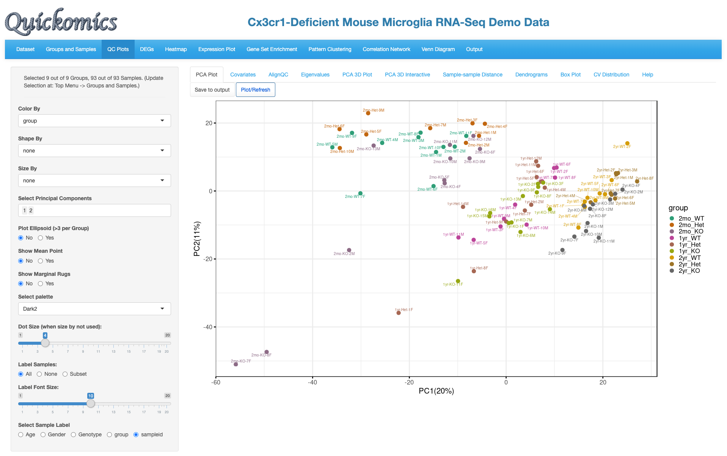

**Label for color**

**Customizable panel**

The “Select Groups” and “Select Samples” feature (Green square) is present in all the QC Plots tabs. The User Is able to remove any particular group or sample from the plots.

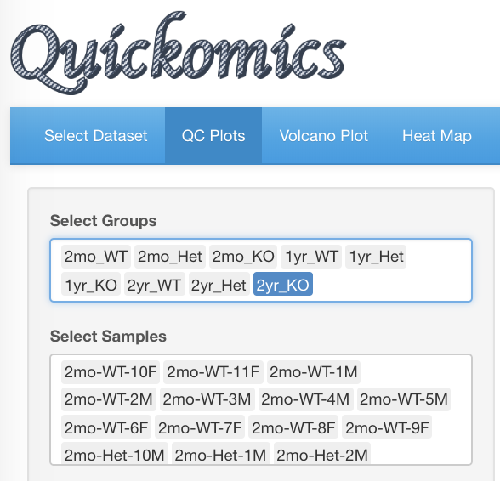 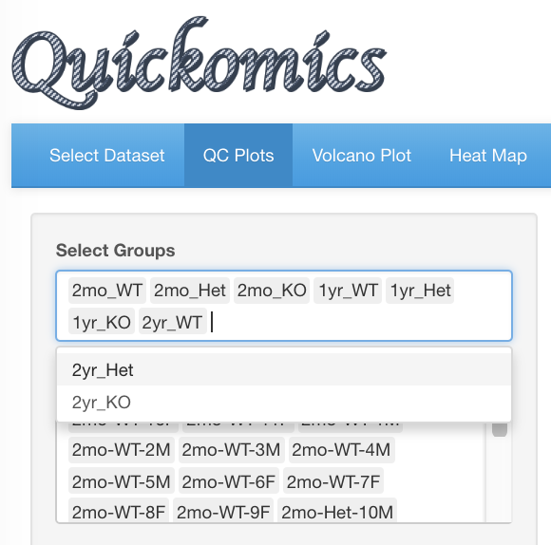

**Delete**

To illustrate the strengths of customization, few different features have been changed below: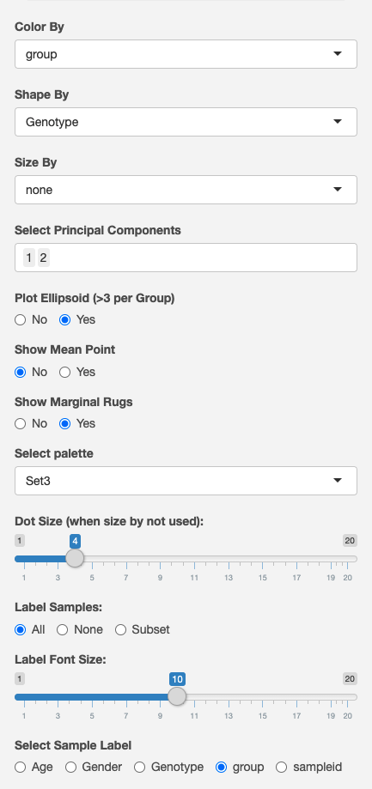

**6.Change to group**

**5.Change palette**

**4.Yes to Margin Rugs**

**3.Yes to Plot Ellipsoid**

**2.Shape by Genotype**

**1.Color by Group**

The resulting selections produce this plot. It is very clear that Age is the factor that drives the biggest separation, especially along PC1. There is some separation driven by the Genotype as well. The Ellipsoid feature helps group samples by the color attribute, while the Marginal Rug feature helps understand the distribution of the color attribute along the axis.

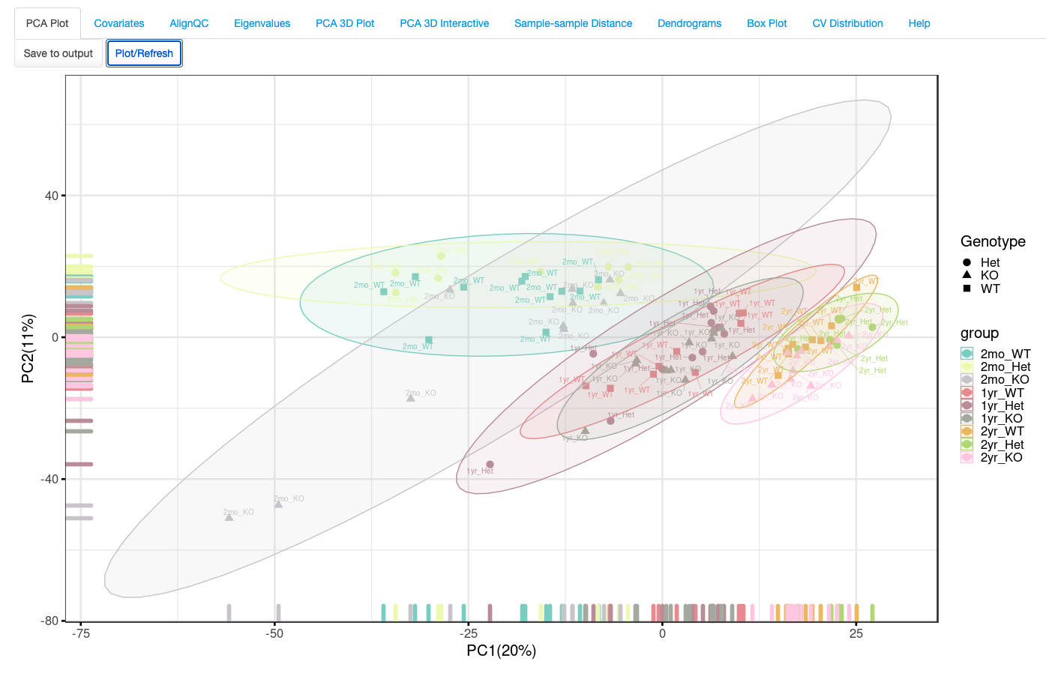

**Click to refresh the plot**

**Click to save**

**Separation by group**

The plot can be saved in high resolution by clicking on “Save to Output”. Section 12 of this document describes the next steps of downloading and obtaining the saved plots.

## Eigenvalues

By default, the PCA plot seen in the previous section (3.1) uses PC1 and PC2. But in many cases, other PC’s may be important in explaining the variance in the dataset. This section plots the variance explained by 10 PCs in the dataset. Users can then make educated decisions of which PCs to plot and use in their PCA analysis. In this dataset PC1 and PC2 together explain around 30% of the variance.

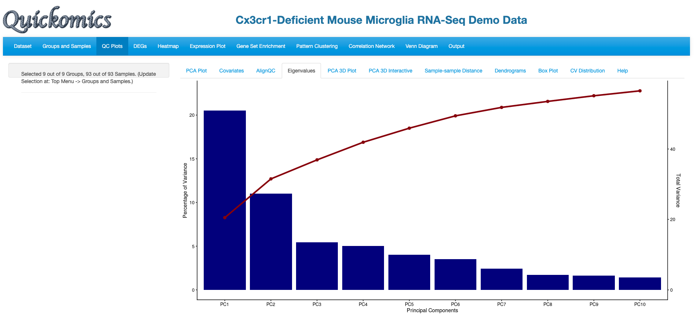

**Cumulative variance**

PC2 and PC3 were used to redo the PCA plot, but here the factors driving the separation of the samples is not as clear.

**Go back to PCA plot**

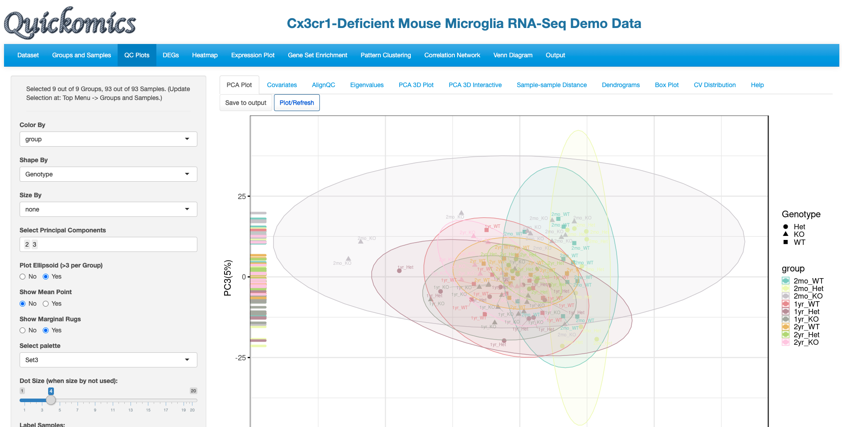

**Change PC to 2 and 3**

**Separation of Genotype not as dramatic as before**

## PCA 3D Plot

This tab provides the ability to perform 3D PCA representation. The functionality is limited to doing so only on PC1, PC2 and PC3. Users can zoom in and out to focus on different areas of the plot or rotate the plot in different axes to view it from different angles. There are 3 attributes that can be changed: color, including an ellipsoid, and to add labels to the samples.

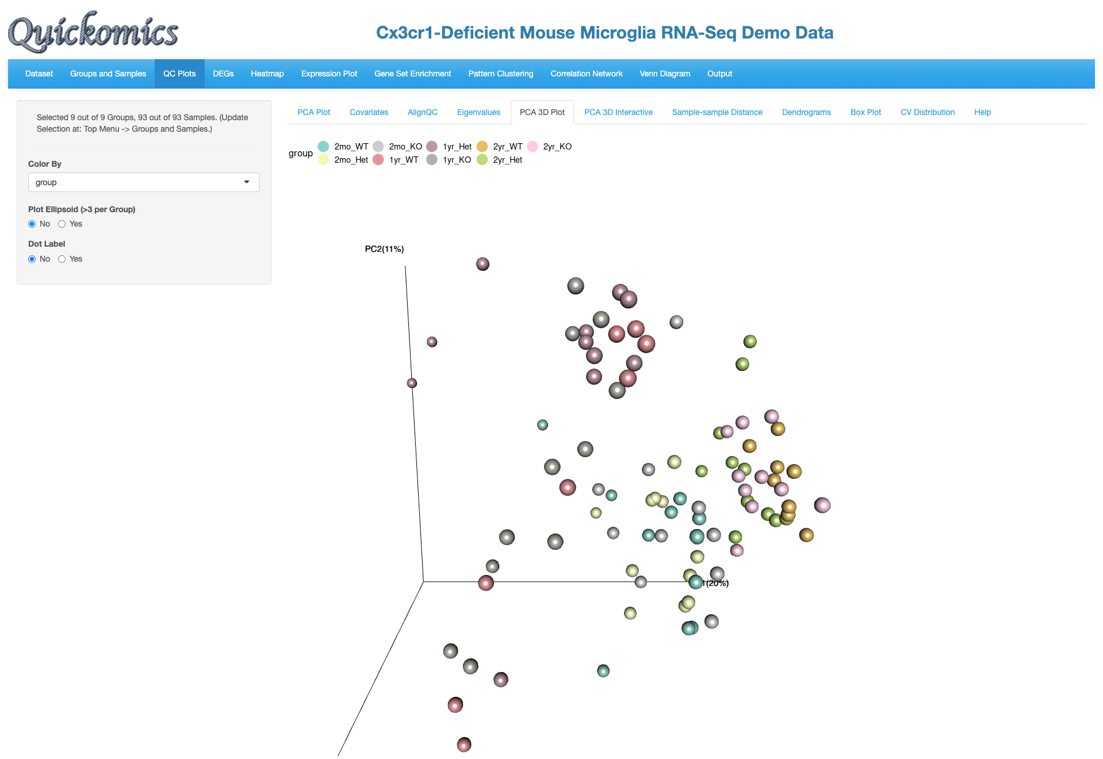

**Rotate the graph to view 3D structure**

The “Color By” and “Plot Ellipsoid” attributes were changed in the following plot. This highlights the clear separation of samples by Age.

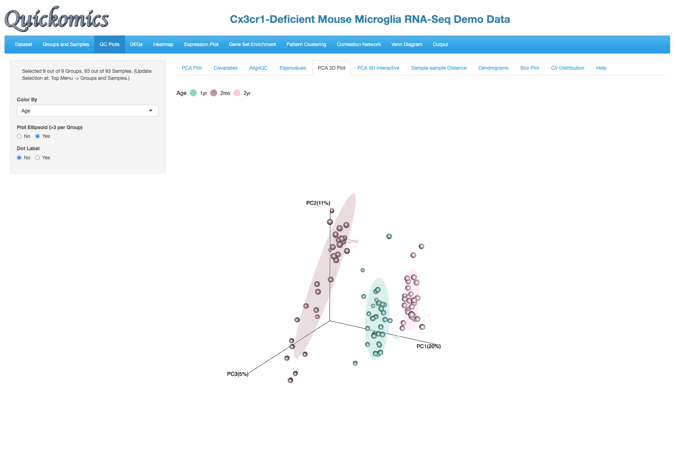

**2.Yes to Ellipsoid**

**1.Color by Age**

**Clear separation by Age**

## PCA 3D Interactive

This tab is similar to the previous one (3.2 PCA 3D Plot), but additionally Users have the ability to hover over the samples on the plot to identify more details, see the pointer below. This was implemented through the plotly package in R. Users can change 2 attributes here, the color and shape.

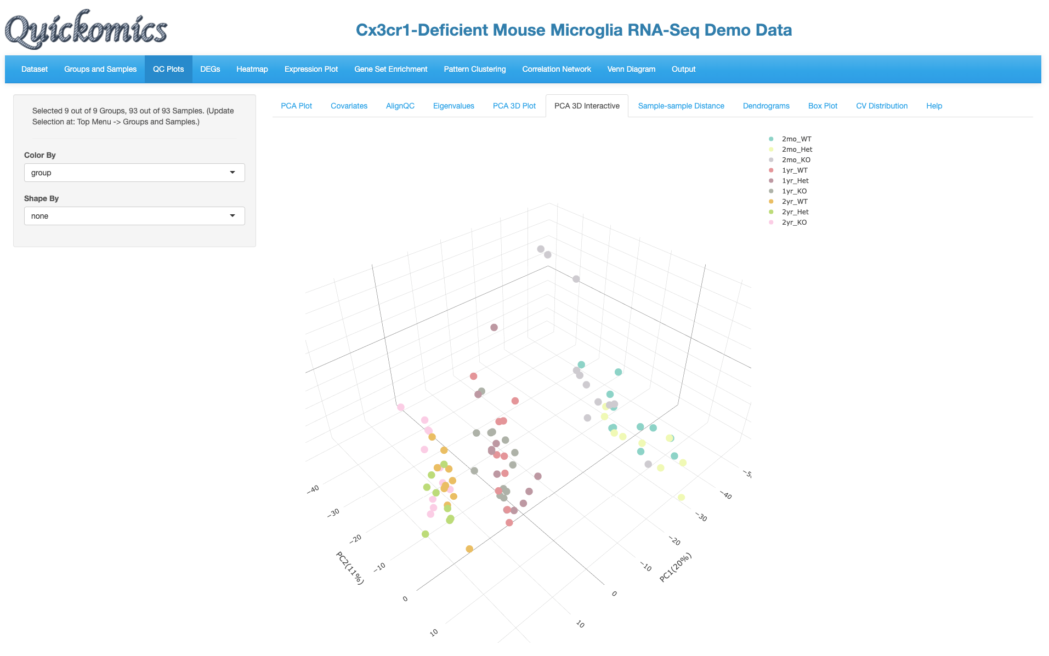

**Hover over sample to get details**

In the plot below, the “Color By” and “Shape By” attributes have been changed to highlight the drivers of separation.

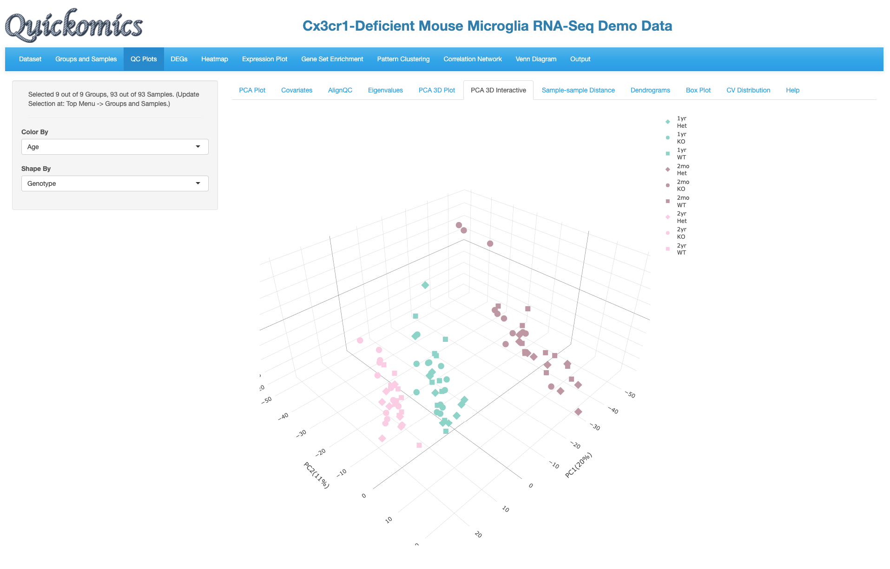

**2.Shape by Genotype**

**1.Color by Age**

## Sample-sample Distance

This tab helps identify pair-wise similarity between all samples. A distance matrix is generated for every sample pair and is plotted as a heatmap using the pheatmap package (ADD REFERENCE). The rows and columns are clustered based on similarity.

It is clear from this plot that samples of the same Age have the smaller distances, that is, they have closer gene expression patterns. Here again, users have the option to save to output.

**Click to save**

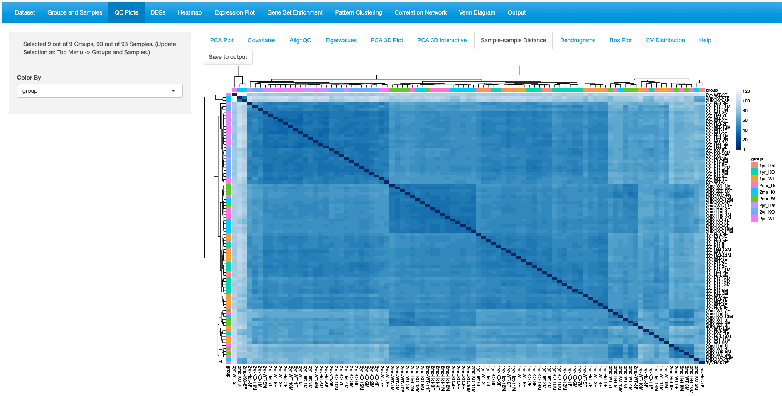

**2mo samples cluster together**

**2yr samples cluster together**

## Dendrograms

Like the previous plot (3.5 Sample-sample Distance), the Dendrogram plot helps visualize hierarchical clustering relationships between samples. The Default plot is Circular and cut into four parts. Users have the ability to visualize in two other ways (tree or horizontal) and cut the plot in multiple regions. Here again, users have the option to save to output.

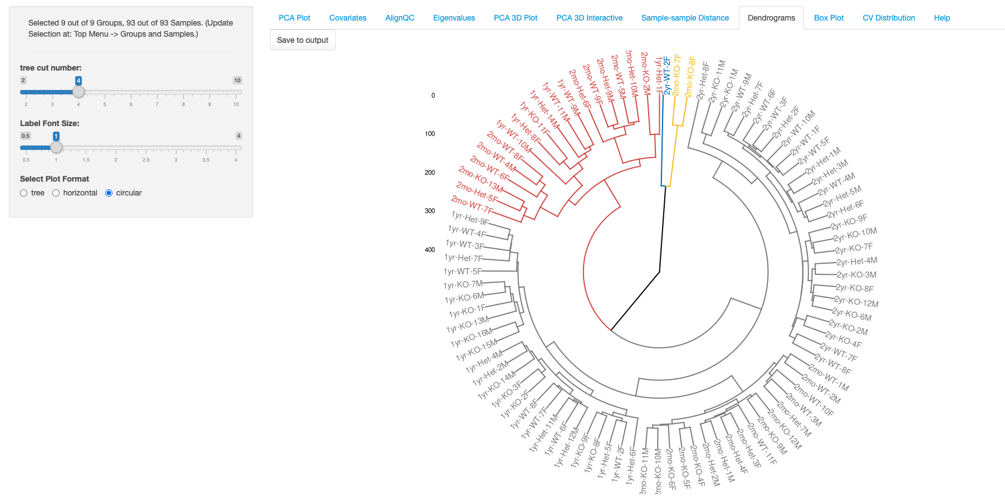

**4 regions don’t separate the Age**

**Click to save**

In the plot below, we have selected to visualize as a tree and cut into eight parts. This shows the relationship between the samples to help understand the hierarchal clustering. Overall, the samples are arranged by age, but there are some outliers that appear. It is also interesting how the 2mon samples cluster with the 1yr samples.

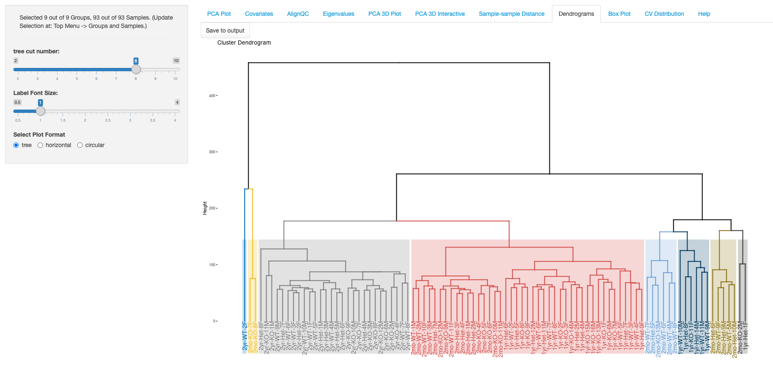

**2.Select tree**

**1.Cut into 8**

**2yr samples cluster together**

## Box Plot

The BoxPlot is a visualization to understand the distribution of the RNA expression in all samples. This identifies the minimum, first quartile, median, third quartile, and maximum values in the dataset. In this demo dataset, most of the samples have the same range of expression.

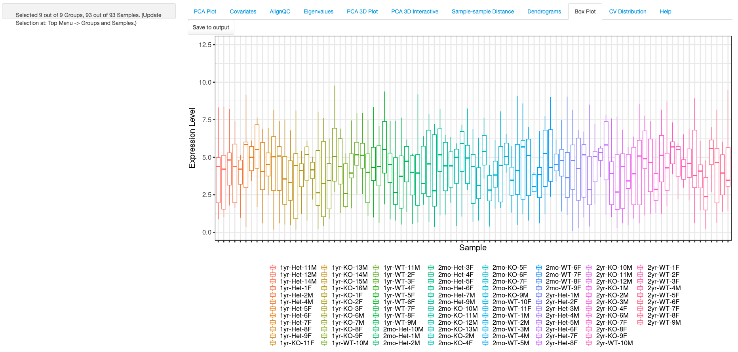

**Click to save**

## CV Distribution

This plot shows the histogram of CV (coefficient of variation) and a dotted line for each group indicates the median CV. In this dataset, the 2mon_KO samples have the highest CV while the 2yr_Het samples have the lowest variability, which corresponds to what is visually seen on the PCA plot for these samples.

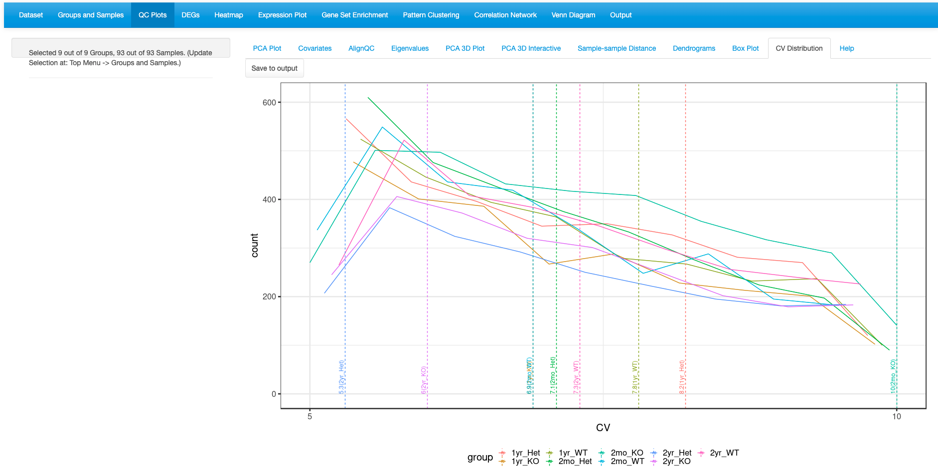

**Median values marked by dotted line**

**Click to save**

## Order Groups

This tab lets the user order the groups, so they are displayed in a preferred order in the other QC plots. Users can either drag and drop the group to reorder, or use the select panel to delete and add. In this example, we have changed the order of the group so that the KO samples are before Het and WT.

|  |  |
| --- | --- |
| Drag and drop | Delete and Add |
|  |  |

The changed groups are now visible. To revert back to the default, Users have the option to click “Reset Groups”.

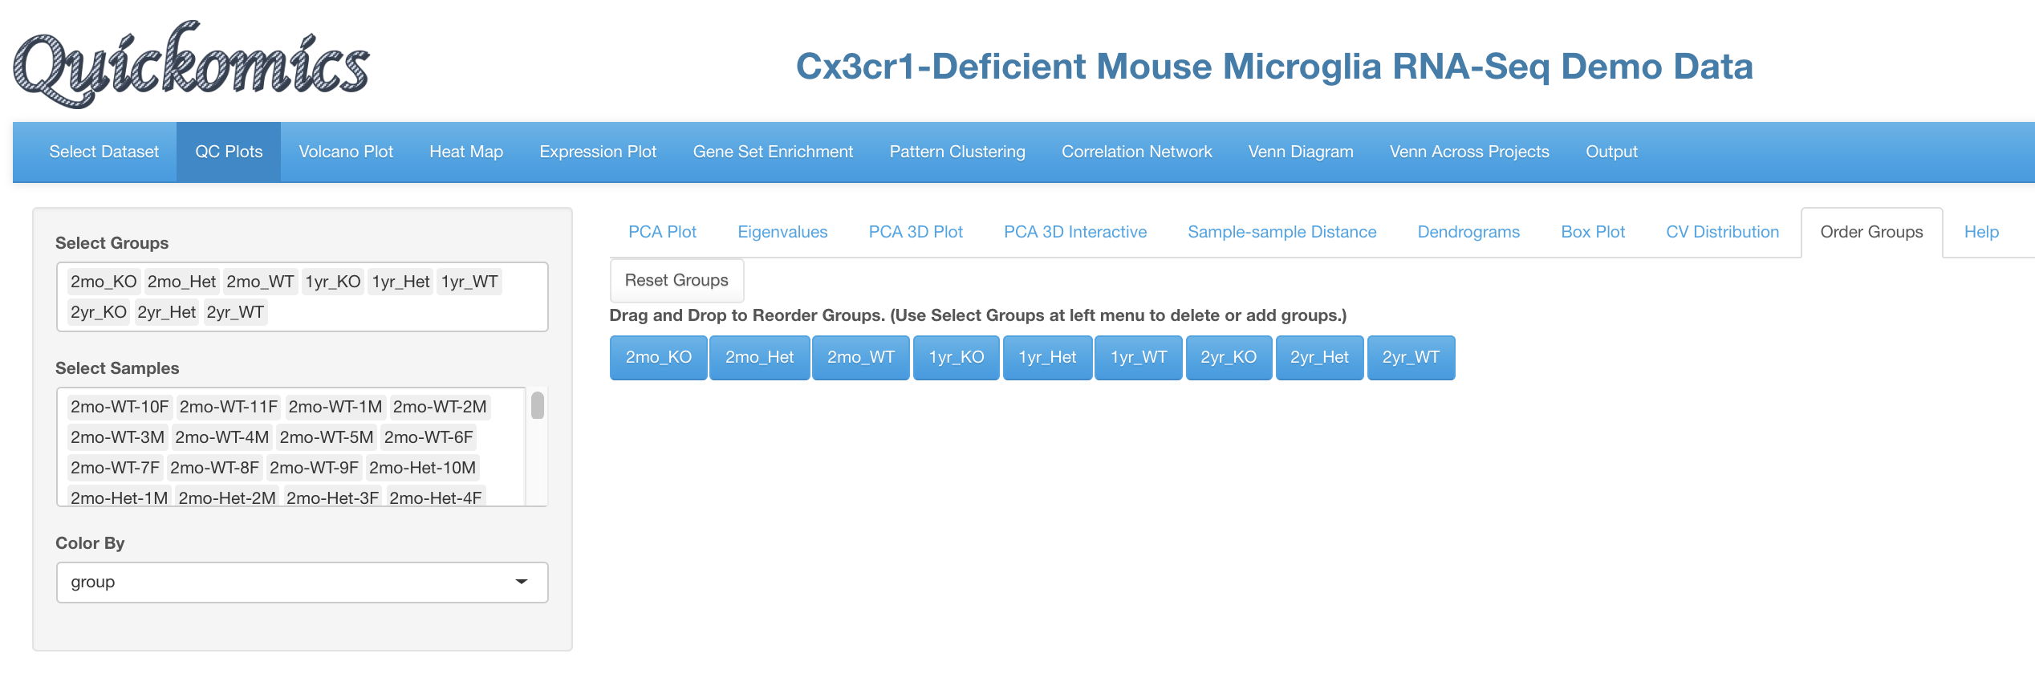

**Changed order**

Going back to the PCA plot, the order of the groups is now changed. This order will also be reflected in all other visualizations in the QC plots.

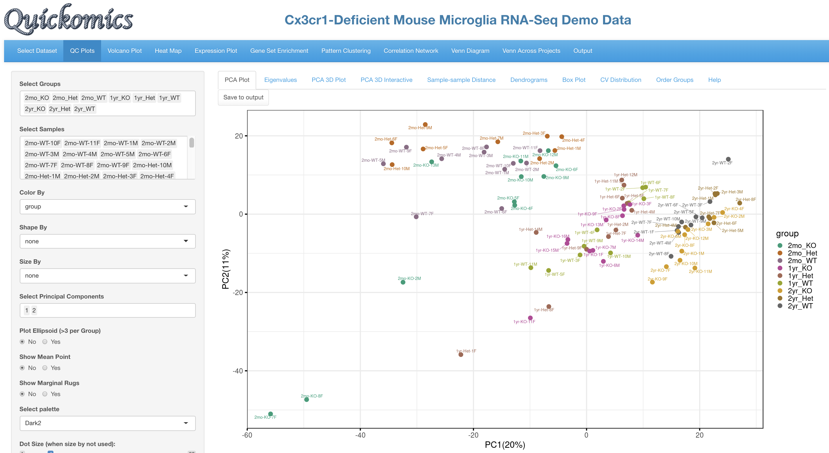

**Changed order of groups**

## Help

The Help section describes each tab of the QC Plot and what is being visualized. For further help please visit the GitHub containing the source code for this tool (<https://github.com/interactivereport/Quickomics>) or click on the link at the bottom of the page.

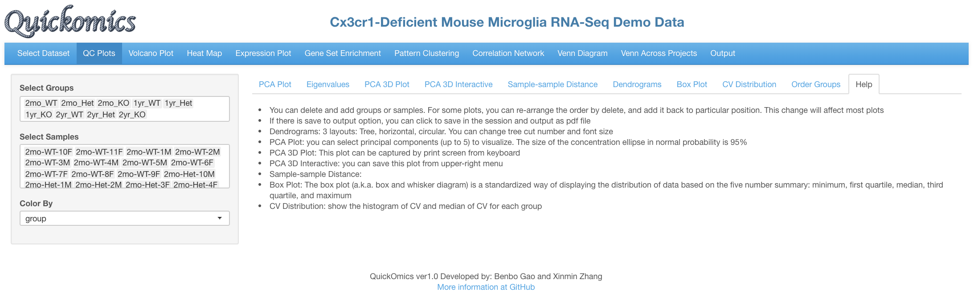

**Click here for further questions**

# Volcano Plot

This section is designed to explore the differentially expressed genes (DEGs) in the dataset. The comparisons are defined by the User when they input the dataset. Please refer to our Github for more details on uploading datasets.

The “Volcano Plot (Static)” described in Section 4.1 and “Volcano Plot (Interactive)” described in Section 4.2 are ways to visualize each pair-wise comparison one by one. “DEGs in Two Comparisons” described in Section 4.3 is a novel way to visualize the similarities and differences in two comparisons. Finally, “Data Table” described in Section 4.4 displays a searchable table containing all genes and their fold changes and p-values in each comparison.

## Volcano Plot (Static)

This plot reveals the differentially expressed genes as identified by the R package DeSeq2 (REF). By default, the Fold change Cutoff is set to 1.2 and the P Value Cutoff is set to 0.01. Users have the option to change any of these parameters. For more advanced display options, they can set the “Show More Options” to “Yes” to customize other settings.

The red dots are indicative of all genes that pass the Fold Change and P Value cutoff, while the green dots are indicative of genes that only pass the P Value cutoff. Fifty random genes are labelled for both the up-regulated and down-regulated genes by default.

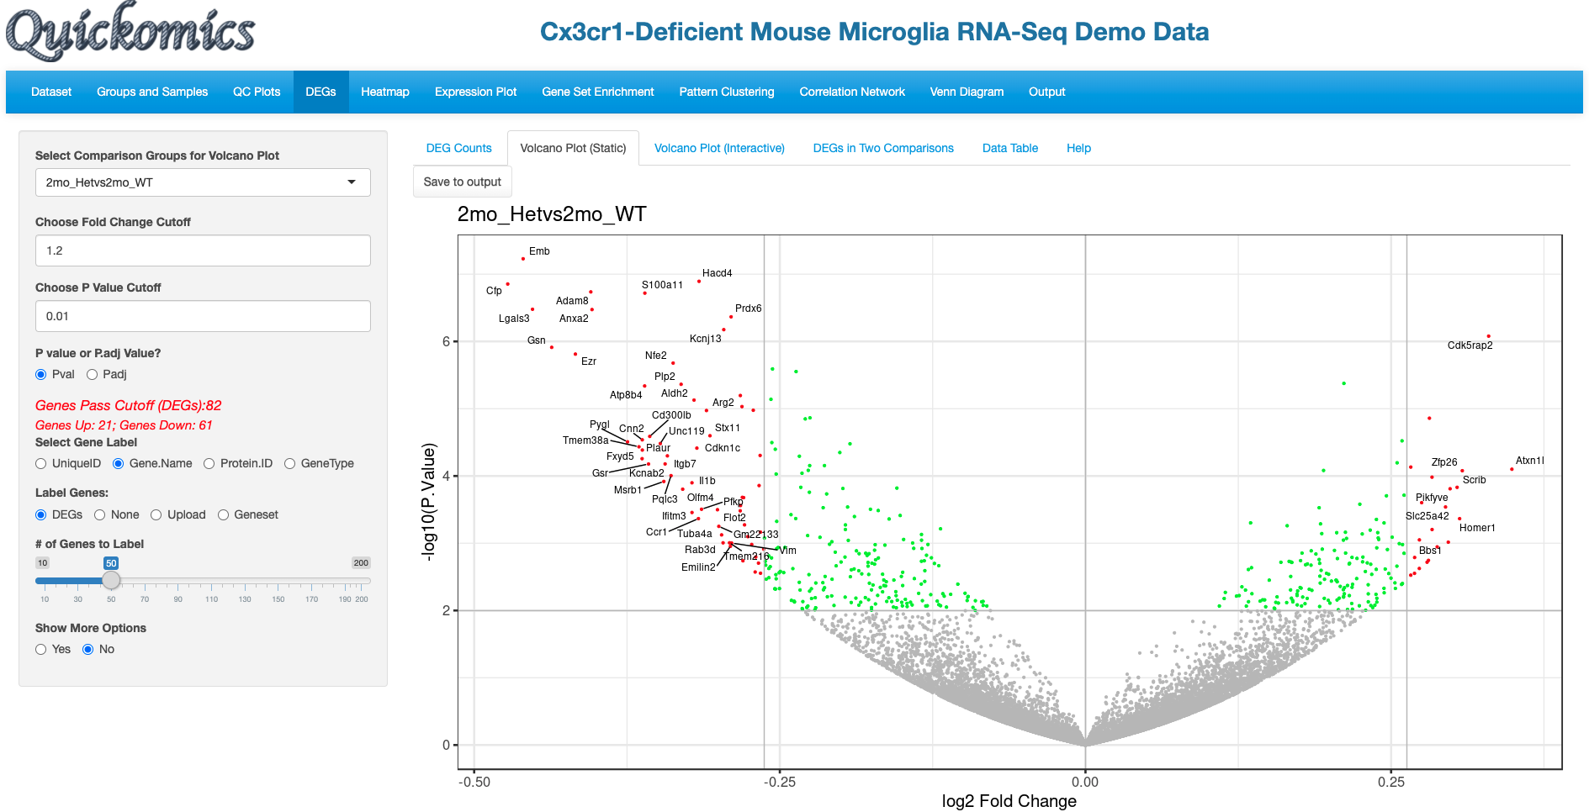

**Default parameters**

**For advanced options set to “Yes”**

**Up-regulated genes**

**Down-regulated genes**

For demonstration purposes, we have changed the following attributes to highlight a few genes in this dataset. We have selected the 2mon_KOvs2mon_WT comparison, where Gyoneva et al., 2019 report immune response genes as the top differentially expressed category. To highlight these genes, in the example below, we select an “Immune Response” dataset from mSigDB (REF) to highlight the genes by adding labels to the volcano plot. As mSigDB contains only human gene lists and the demo dataset is from mouse, Quickomics does a quick conversion of the names of Human genes to Mouse genes by changing the letters after the first one to lowercase. Additionally, in this example we removed some of the genes from the list to reduce size.

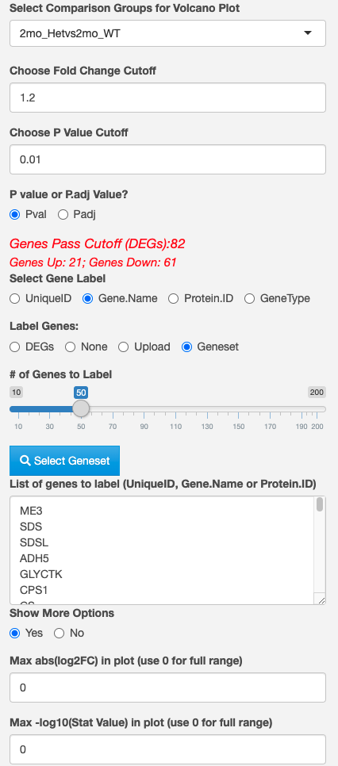

**Select comparison**

**Search for a particular keyword**

**Change Fold Change**

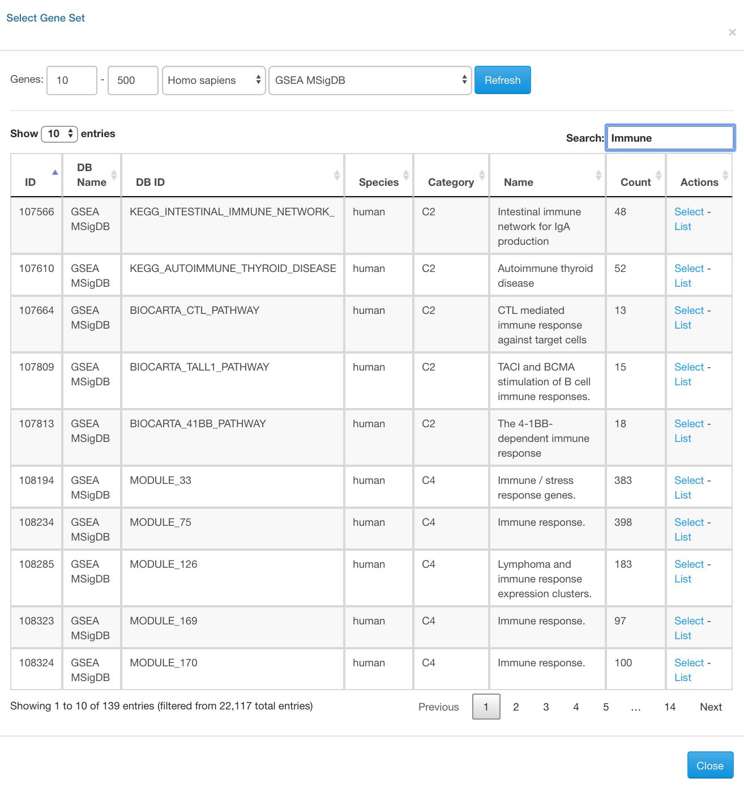

**Select Database**

**Select padj**

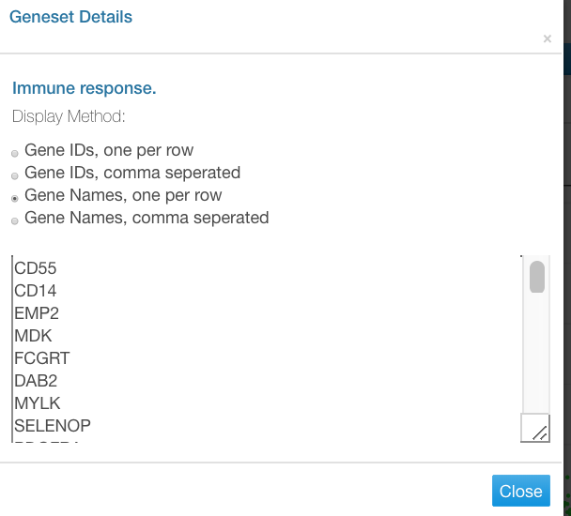

**Select Geneset**

**To view genes in a group**

**Add or remove any gene**

**For customizing the axis limits in the plot**

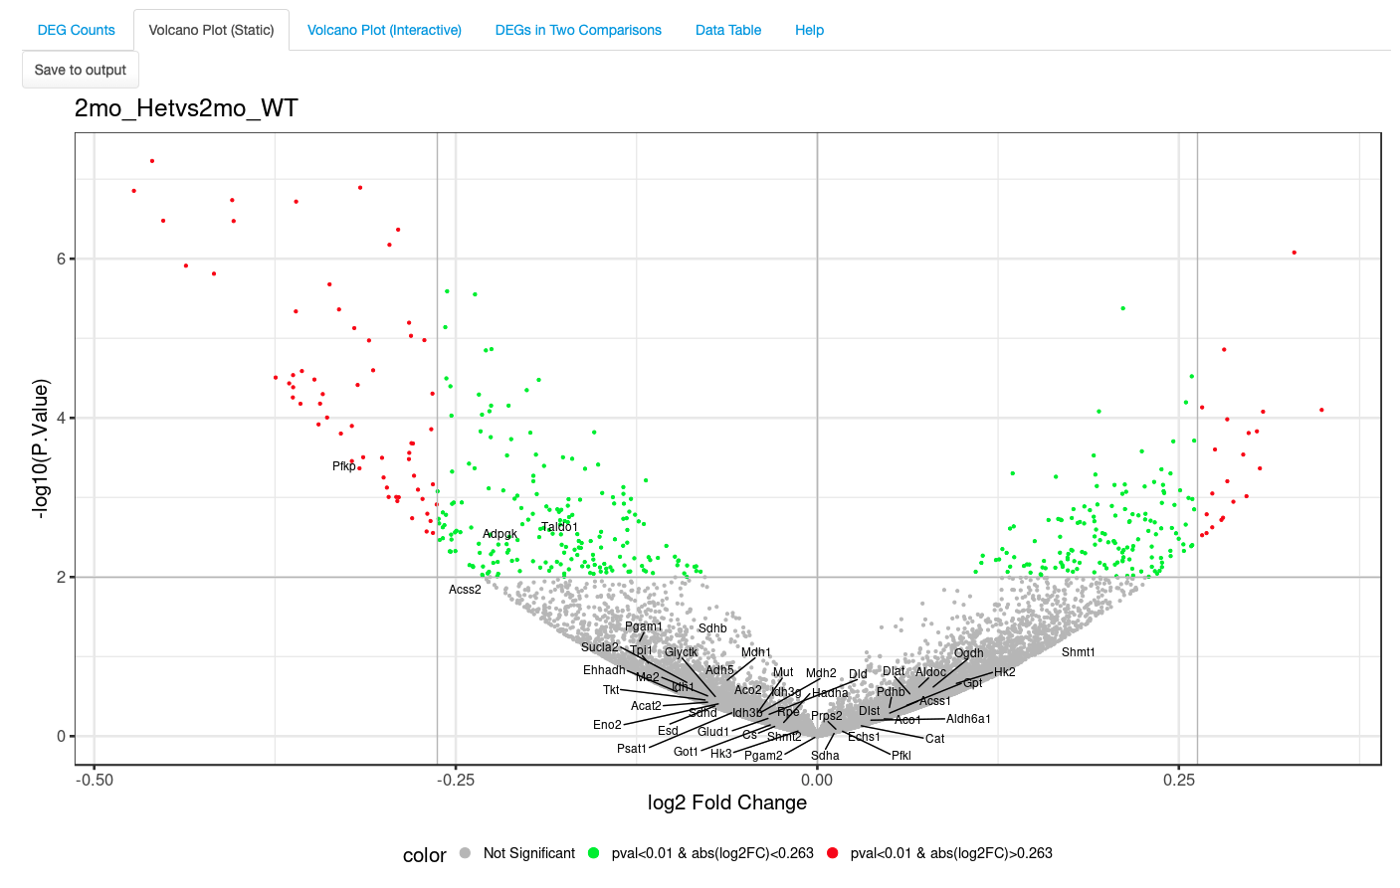

**Resulting plot highlights the genes are downregulated**

**Click to save plot**

## Volcano Plot (Interactive)

This next tab is a very similar visualization as the previous one (4.1 Volcano Plot (Static)) with an additional capability where users can hover over a particular dot/gene on the plot to see more details. This plot has a few attributes that can be changed, and in the example below we have used the same cutoffs and values as in section 4.1.

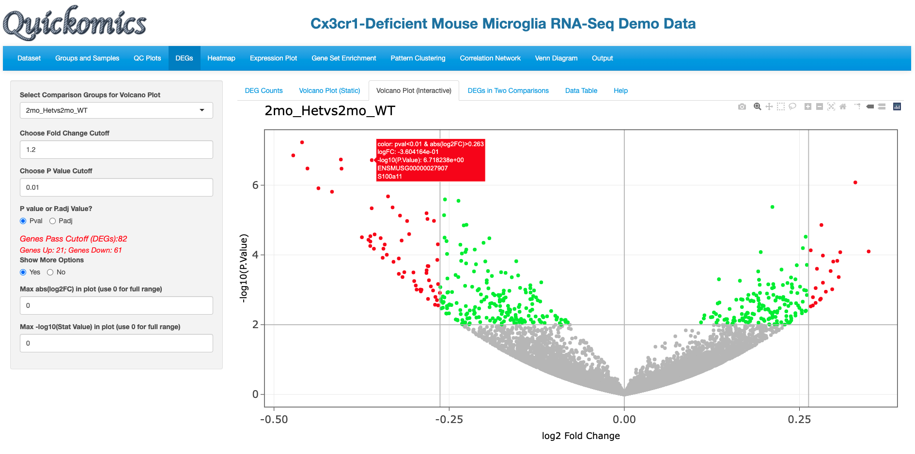

**For customizing the axis limits in the plot**

**Select Padj**

**Hover over a gene for more details**

**Change Fold Change**

**Select comparison**

## DEGs in Two Comparisons

This next tab helps with identifying Differentially Expressed Genes (DEGs) that follow a similar trend in two comparisons. Gyoneva et al., 2019, the source of this demo dataset, report that the genes differentially expressed in Cx3cr1 KO microglia in the 2mon KO are quite different from WT, while the differences from WT are smaller for the 1yr KO and 2yr KO, and the two older ages are similar to each other. We have plotted out the following comparisons that illustrate this conclusion.

2mo_KOvs2mo_WT vs 1yr_KOvs1yr_WT has a low correlation score. There are many genes that are colored yellow, meaning those genes were significant in 2mo_KOvs2mo_WT (Y axis) but not in 1yr_KOvs1yr_WT (X axis).

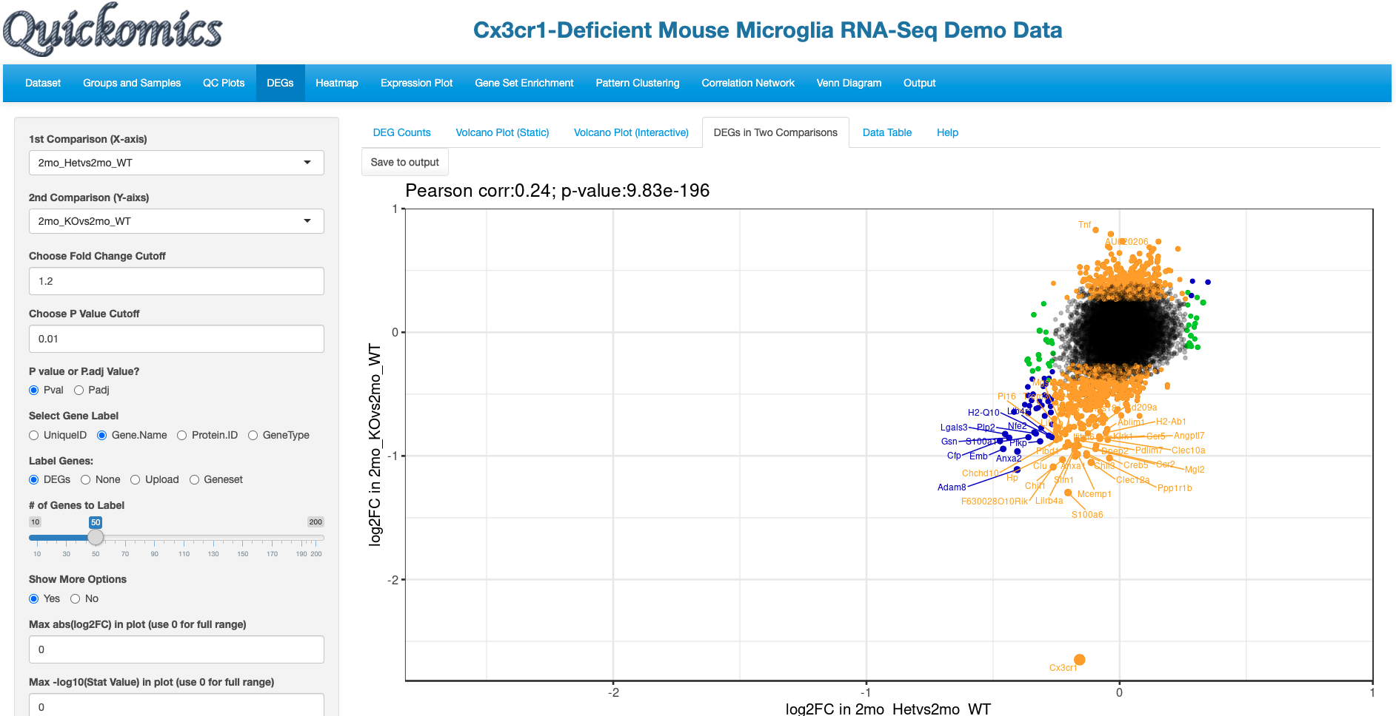

**For customizing the axis limits in the plot**

**Select Yes**

**Select Padj**

**Change Fold Change**

**Select comparison 1**

**Select comparison 2**

**Corr score**

**Save to output**

Similarly, we changed the X axis to 2yr_KOvs2yr_WT to compare to 2mo_KOvs2mo_WT, and it shows a very similar plot with a low correlation score of 0.178

**Save to output**

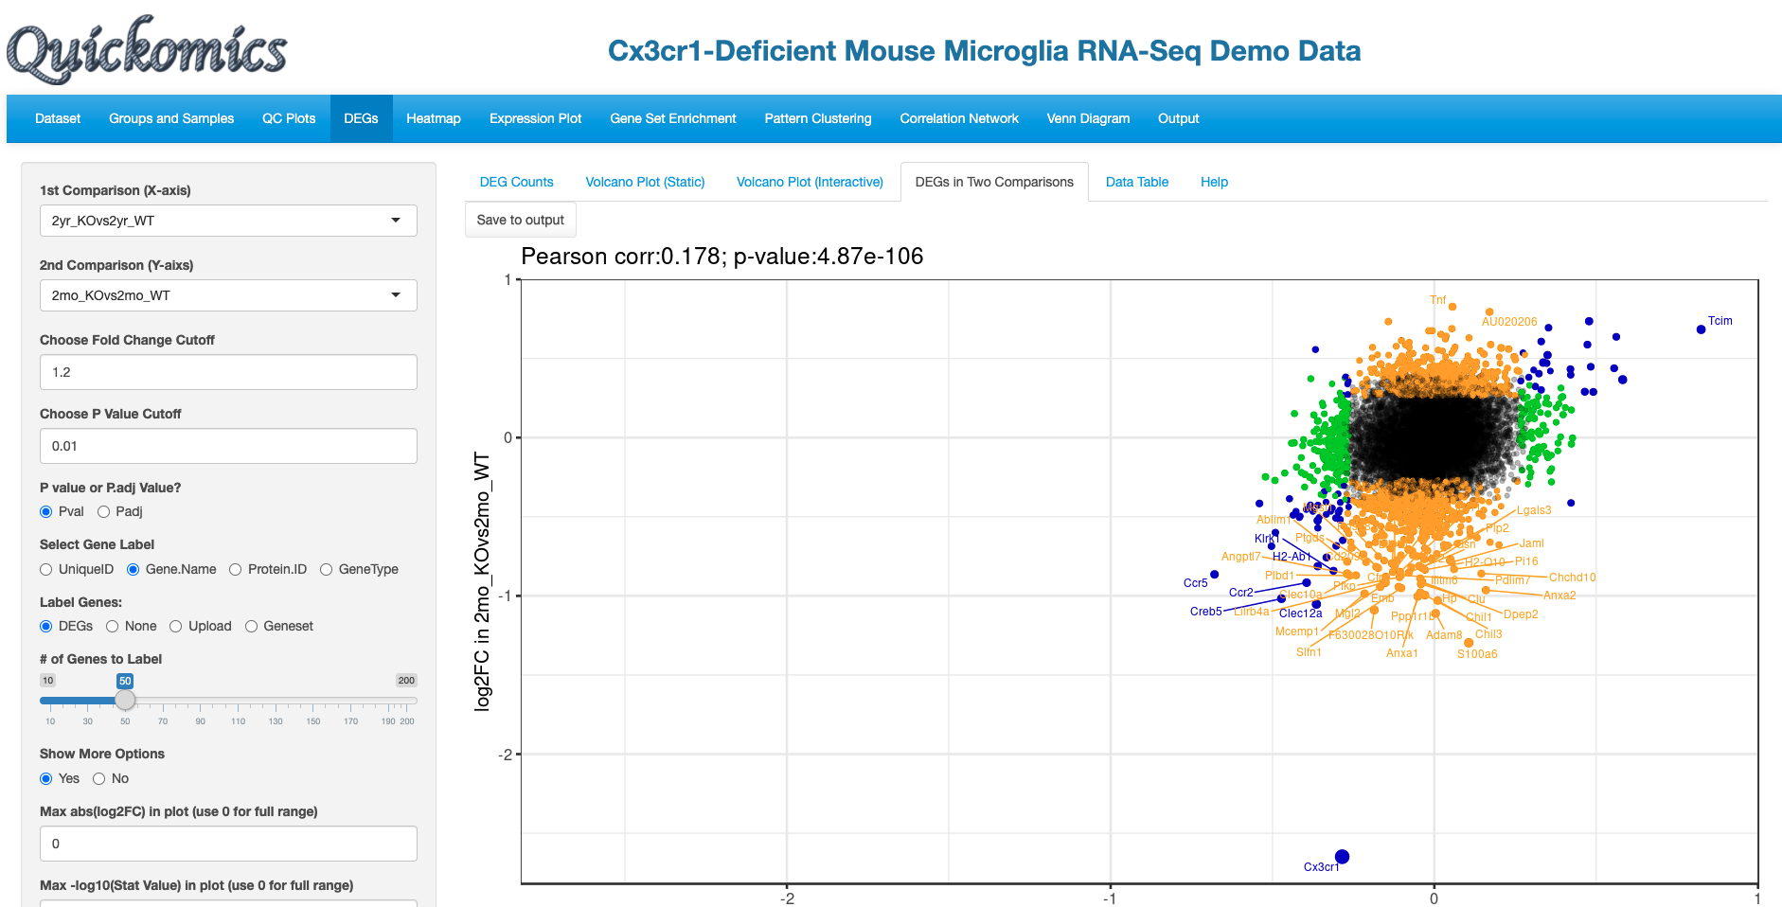

**Change comparison 1**

**Corr score is 0.178 v**

Next, we changed the Y axis comparison to 1yr_KOvs1yr_WT comparing it to 2yr_KOvs2yr_WT on the X axis. This plot has a higher correlation score of 0.371 than the previous one, suggesting that these two comparisons are more similar. These comparisons represent additional insights supported by statistical analyses that were gained from the data and were not available in the original manuscript by Gyoneva et al.

**Save to output**

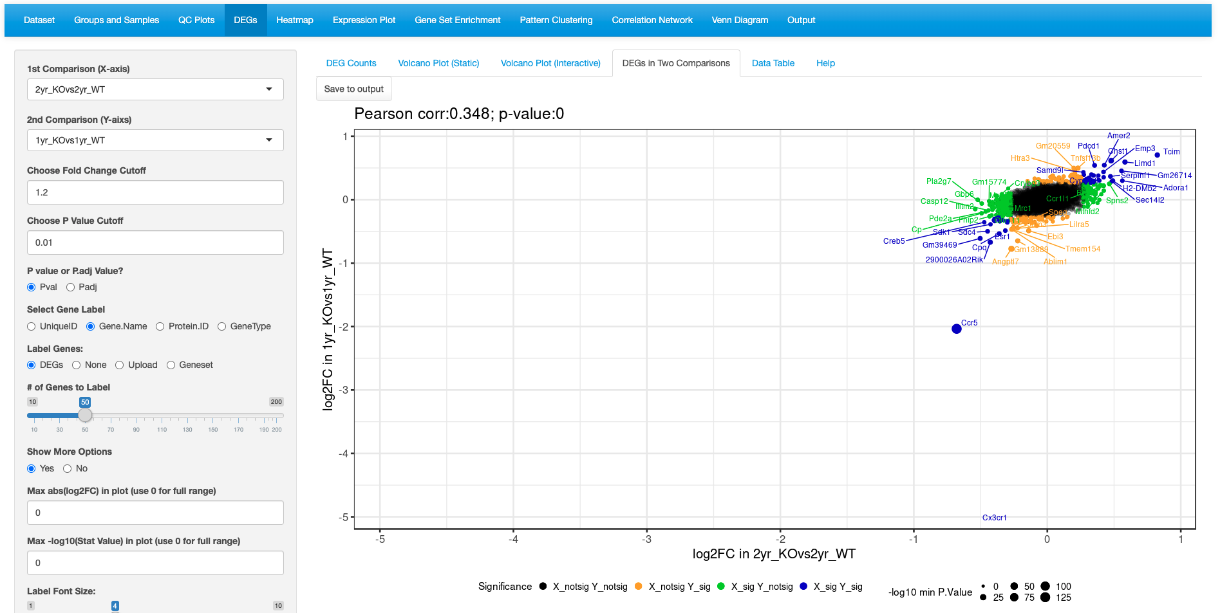

**Change comparison 2**

**Corr score is 0.348 v**

## Data Table

This tab lets the users view the Differentially Expressed Genes (DEGs) in a tabular format with a searchable feature. Users also have the ability to download the gene list as a CSV.

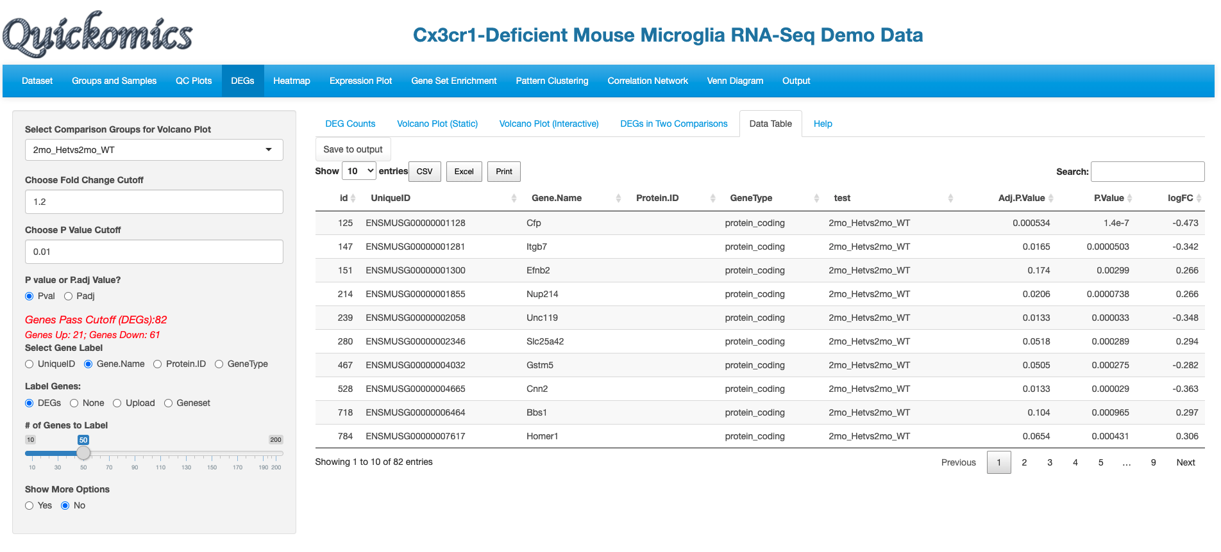

**Click on any column to sort the list**

**Search for any gene**

**Save whole list to output**

**Download the current page as CSV, Excel or Pdf**

**Choose cutoffs**

**Select comparison**

# Heat Map

This section of Quickomics produces highly customized Heatmaps that are publication quality. We have used pheatmap package from R to generate these plots. Users can enter automated list of differentially expressed genes or enter a list of genes of their own. This section is slightly different from other sections in that each time Users change the attributes, they need to click on the “Plot/Refresh” button to generate the plot.

## Static Heatmap Layout 1

For demo purposes, we have selected options that highlight some capabilities to generate informative Heatmaps. For gene selection the default option is the selection of 100 random genes which can also be changed to variable genes. Here we selected DEGs from the 2yr_WTvs2mon_WT comparison. Users also have the option to change the cutoff criteria for filtering the genes. They can also add/remove annotation categories for the samples on the columns.

In this heatmap the top up-regulated genes in 2mon_WT samples are seen as high in 2mon samples but low in 2yr and 1yr samples, while the top up-regulated genes in the 2yr_WT samples are high in the 2yr and 1yr samples but low in the 2mon samples. This is another example that the 2mon microglia have a different gene expression profile compared to 1yr and 2yr.

**Top up-regulated genes in 2yr_WT are also high in 1yr samples**

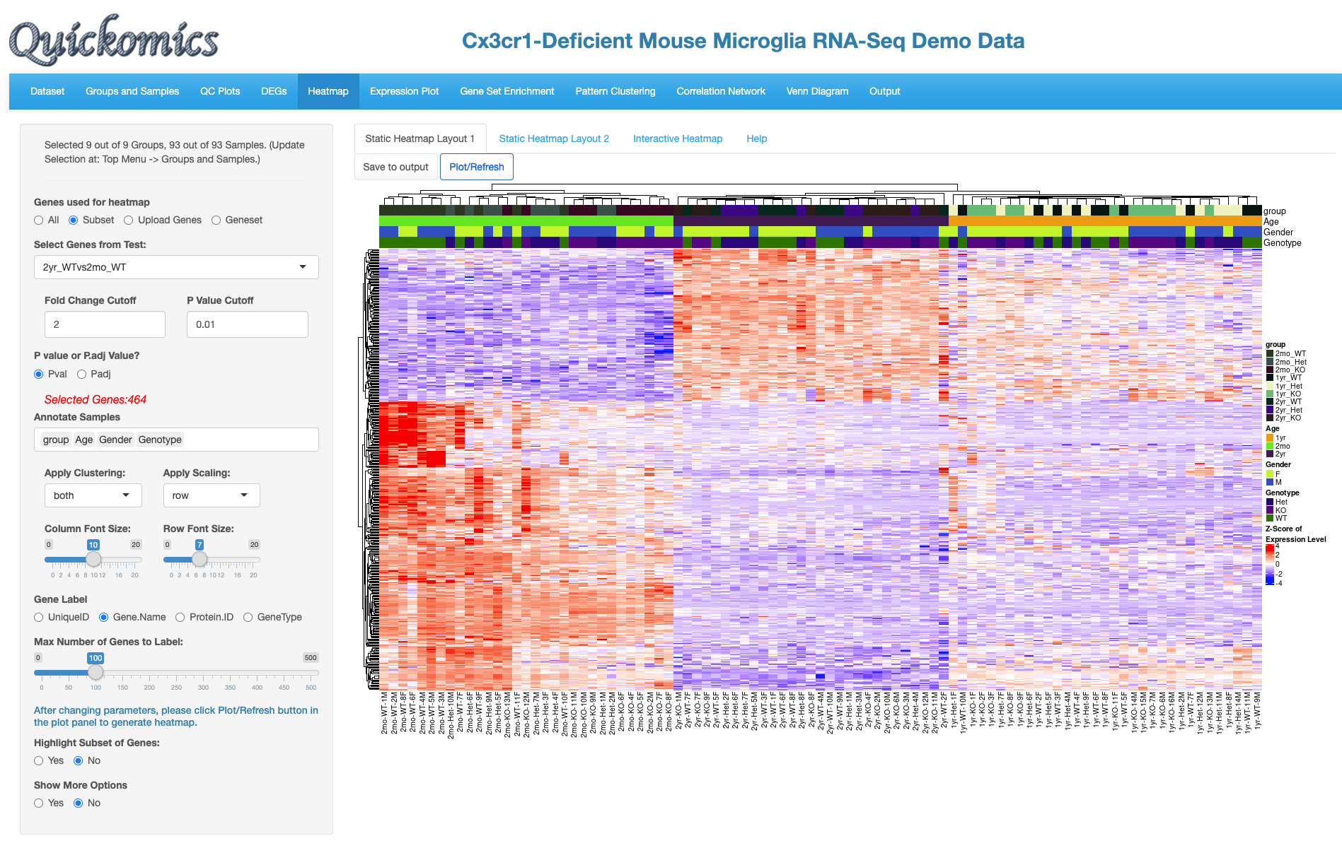

**Top up-regulated genes in 2yr_WT**

**4.Click Plot/Refresh to view**

**Column annotation legend**

**Each column is 1 sample**

**Each row is 1 gene (out of 464)**

**Top up-regulated genes in 2mon_WT**

**3.Annotation categories for columns**

**2.Select comparison and pick cutoffs**

**1.Change genes to “Subset” for DEGs**

In this next example, we customize another Heatmap to highlight immune related genes that were called out in Gyoneva et al., 2019.

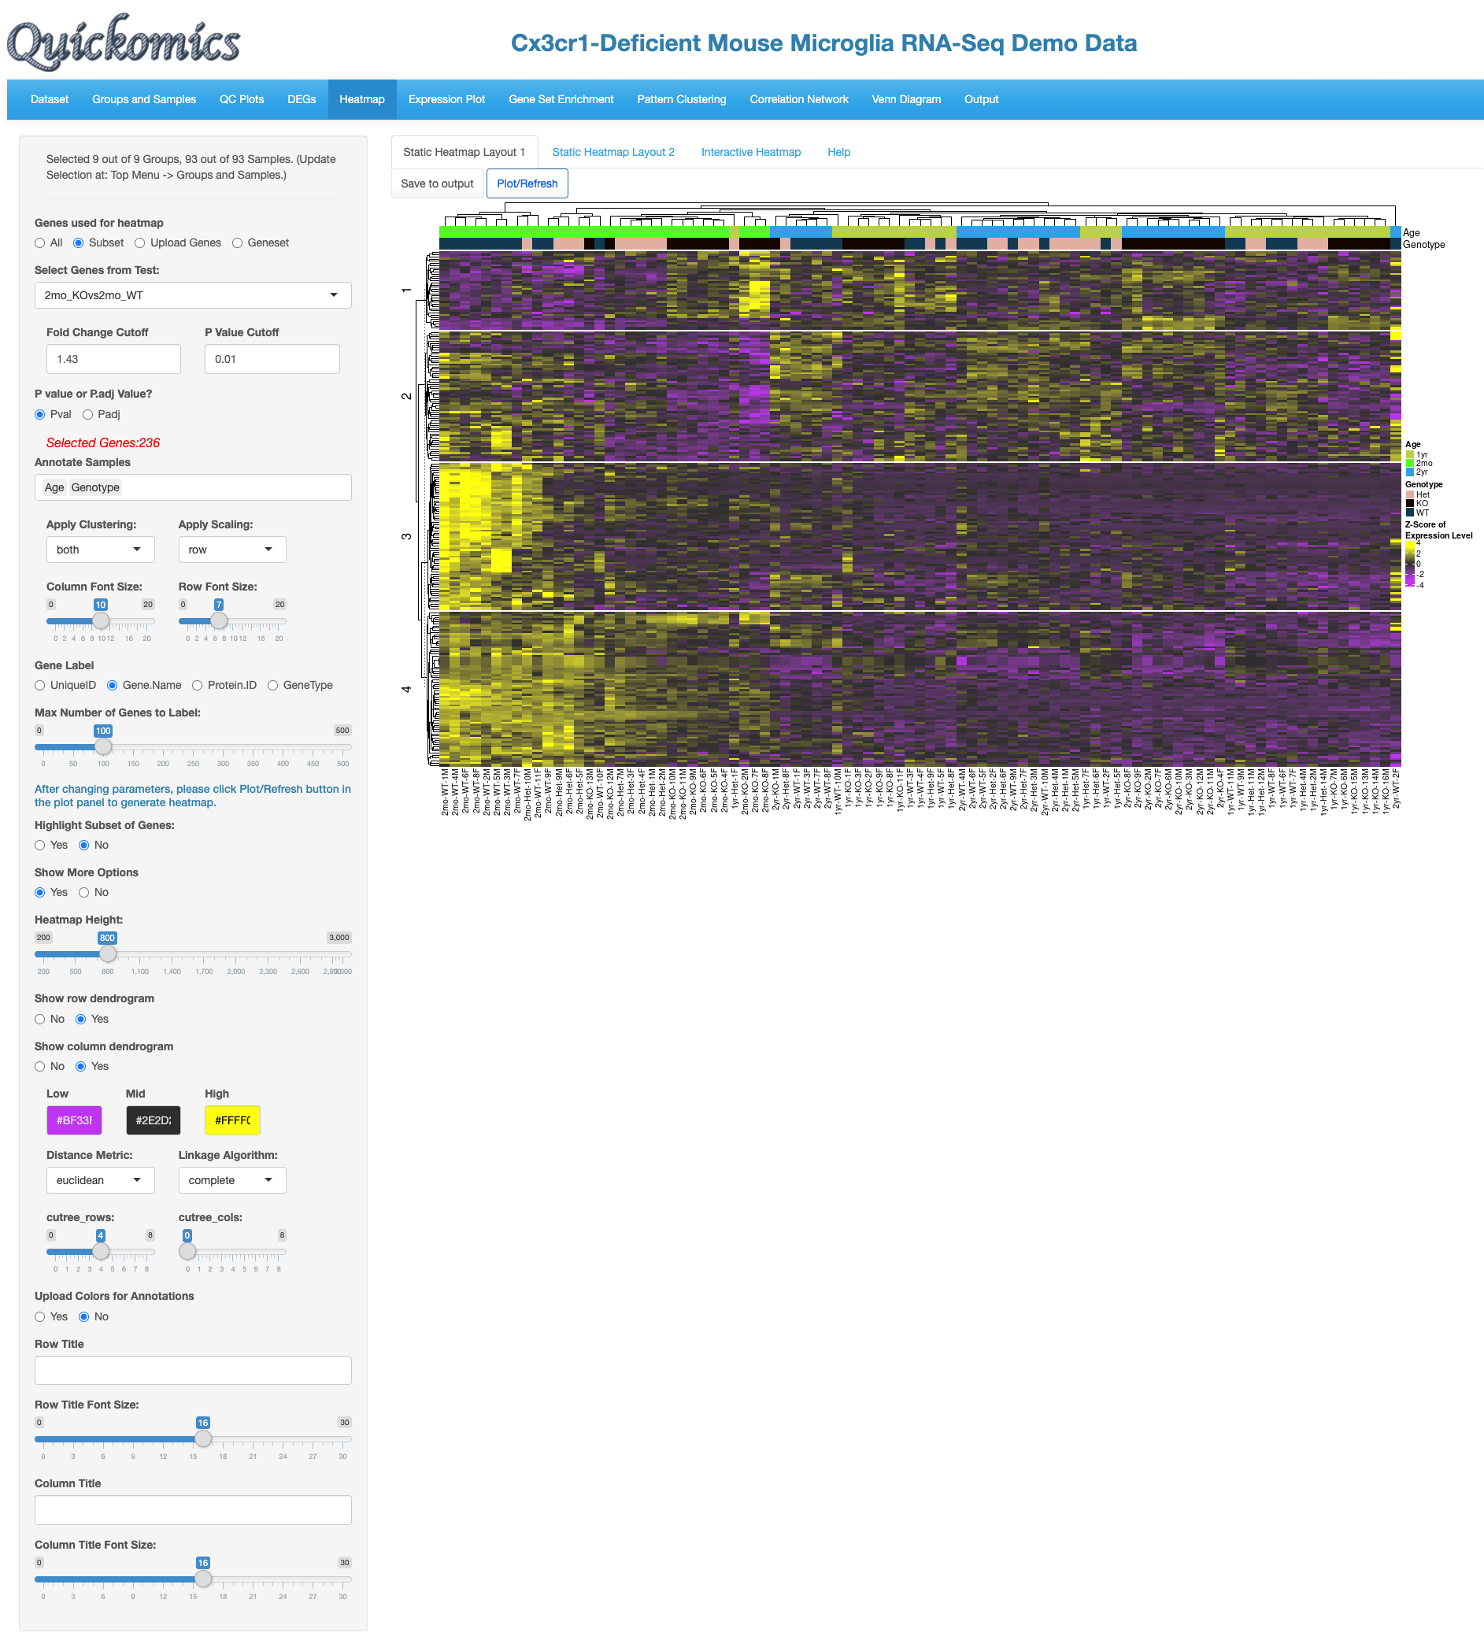

**Click to save**

**6. Cut tree**

**5. Color schema**

**2.Change cutoff to restrict no of genes**

**Genes are cut into 4 parts**

**3.Restrict annotations**

**4. Font sizes**

**1.Change comparison**

## Static Heatmap Layout 2

This next tab generates a stiller different heatmap layout using heatmap.2 in gplots package in R. Here is a demo of the same set of genes with dendrograms for both rows and columns.

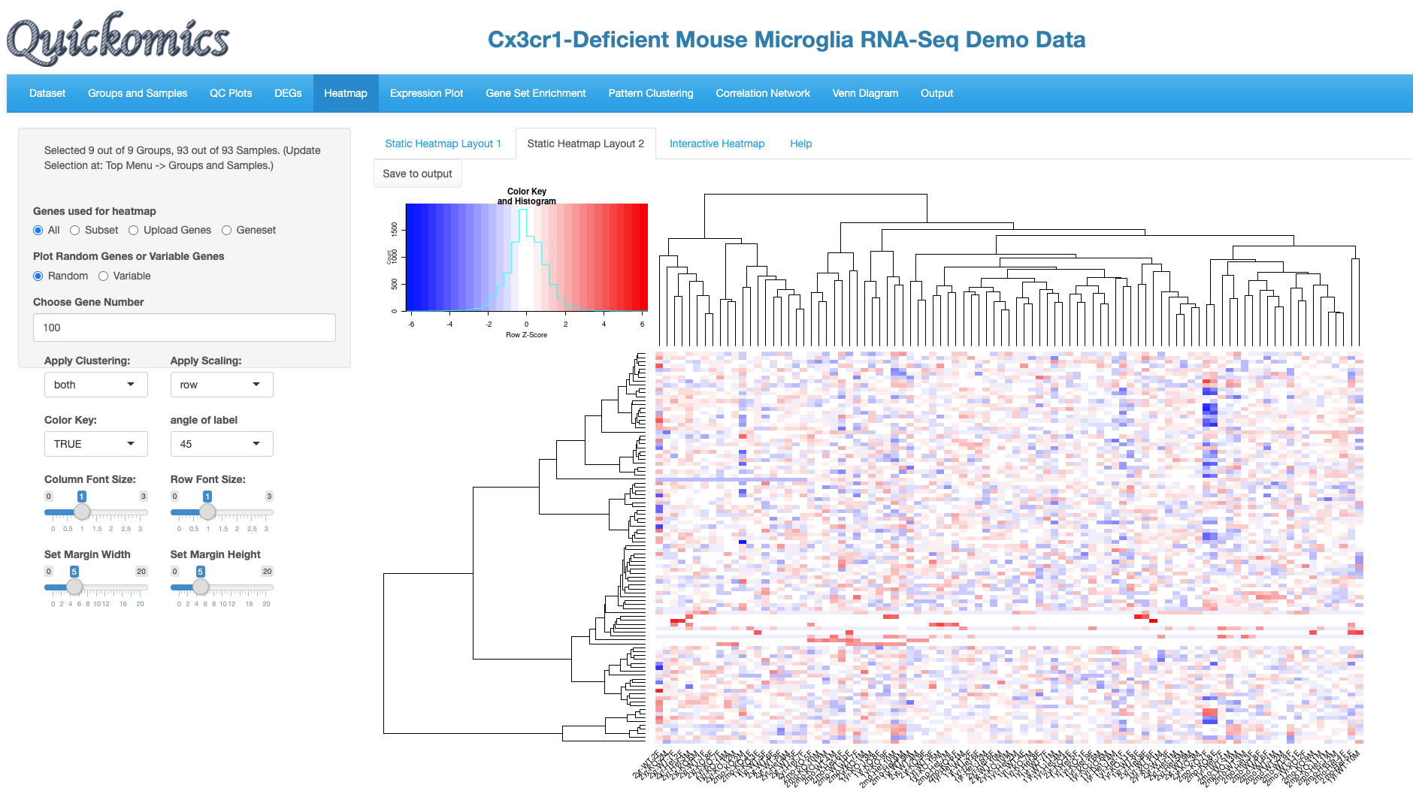

**2.Change cutoff to restrict no of genes**

**Click to save**

**1.Change gene set**

# Expression Plot

This functionality in Quickomics offers Users the ability to plot expression of individual genes in different formats like Box Plot, Bar Plot, Violin Plot or Line Plot.

## Browsing

This tab lets the Users plot out the expression of the DEGs identified in the different comparisons. In this example below, we demonstrate how to display a few top genes as Violin Plots.

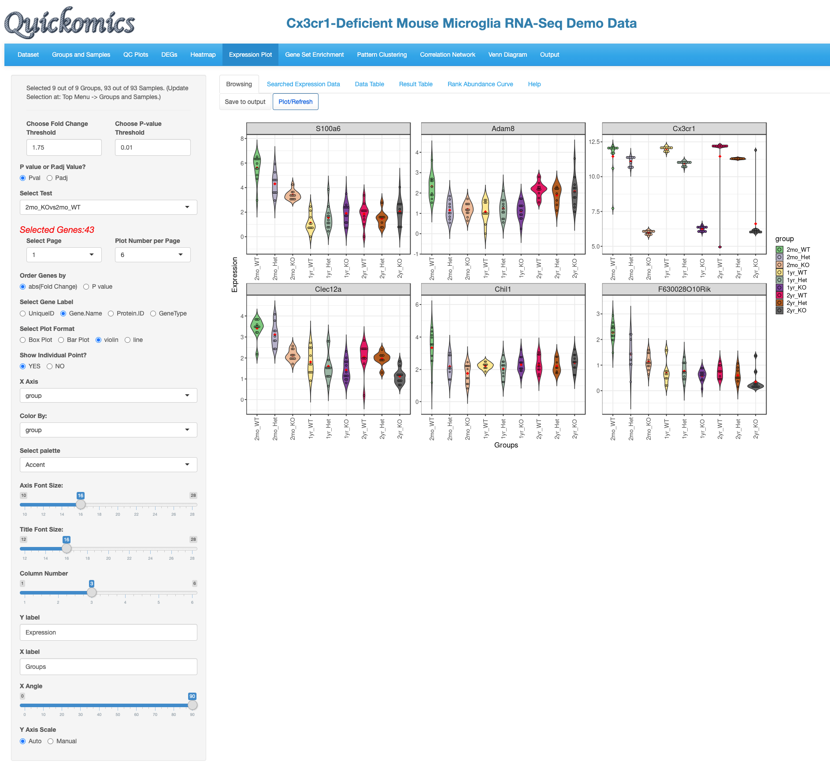

**First 6 genes are displayed**

**4.Add custom X and Y axis labels**

**3.Select display options**

**1.Select cutoffs to filter genes**

**2.Select comparison**

## Searched Expression Data

Another way to plot genes is using this functionality. Users can either enter a list of genes themselves or select a list from online databases like Kegg, mSigDB etc. Here is an example of plotting genes involved in MHCII antigen processing plotted in one bar plot.

**2.Select Mus musculus**

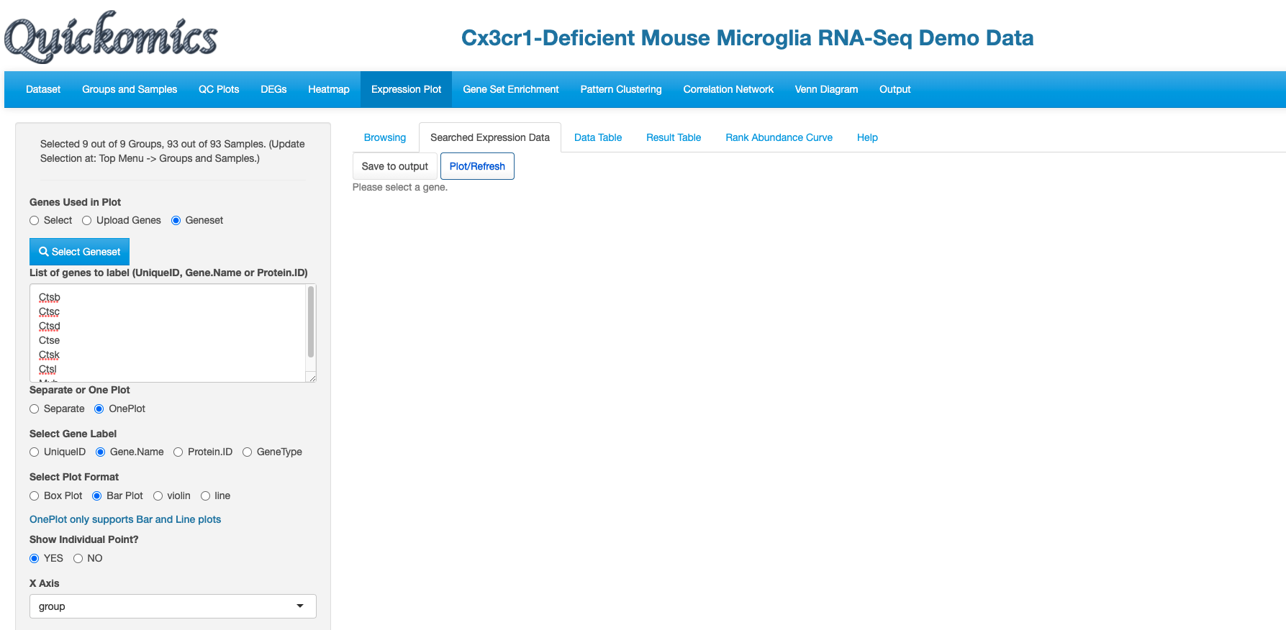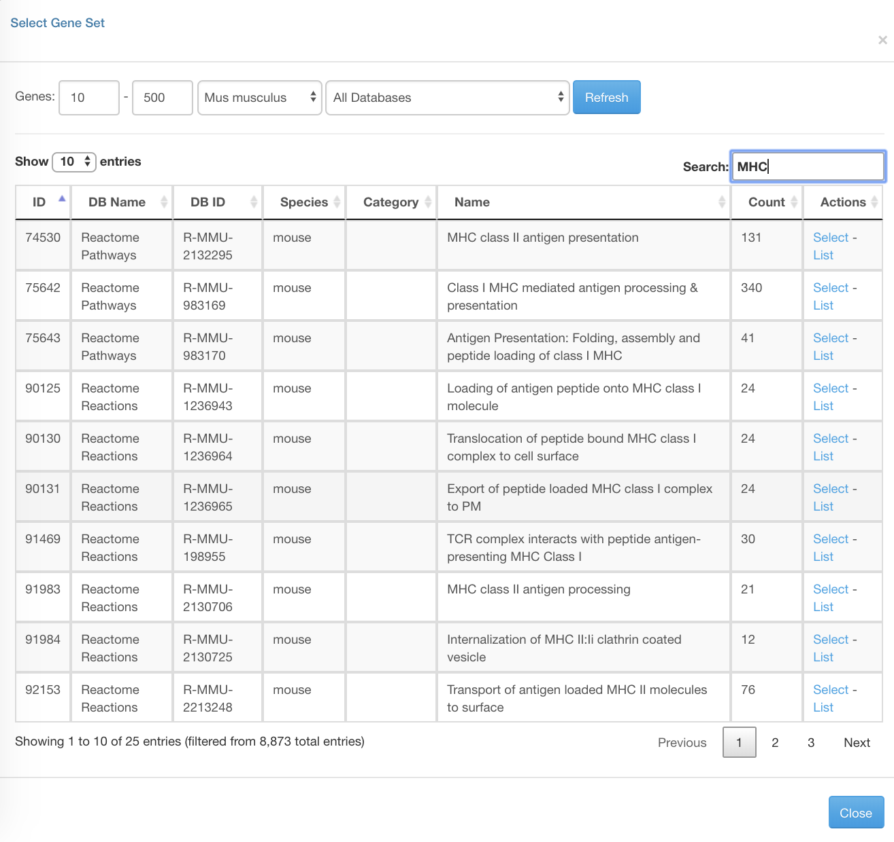

**3.Search “MHC”**

**6.Click Plot/Refresh**

**5.Select display options**

**4.Select OnePlot**

**1.Select Geneset**

**4.Select list**

The resulting plot shows the differences in the family of genes within the different groups. Most of these genes remain constant in expression across the different groups.

**Click to save**

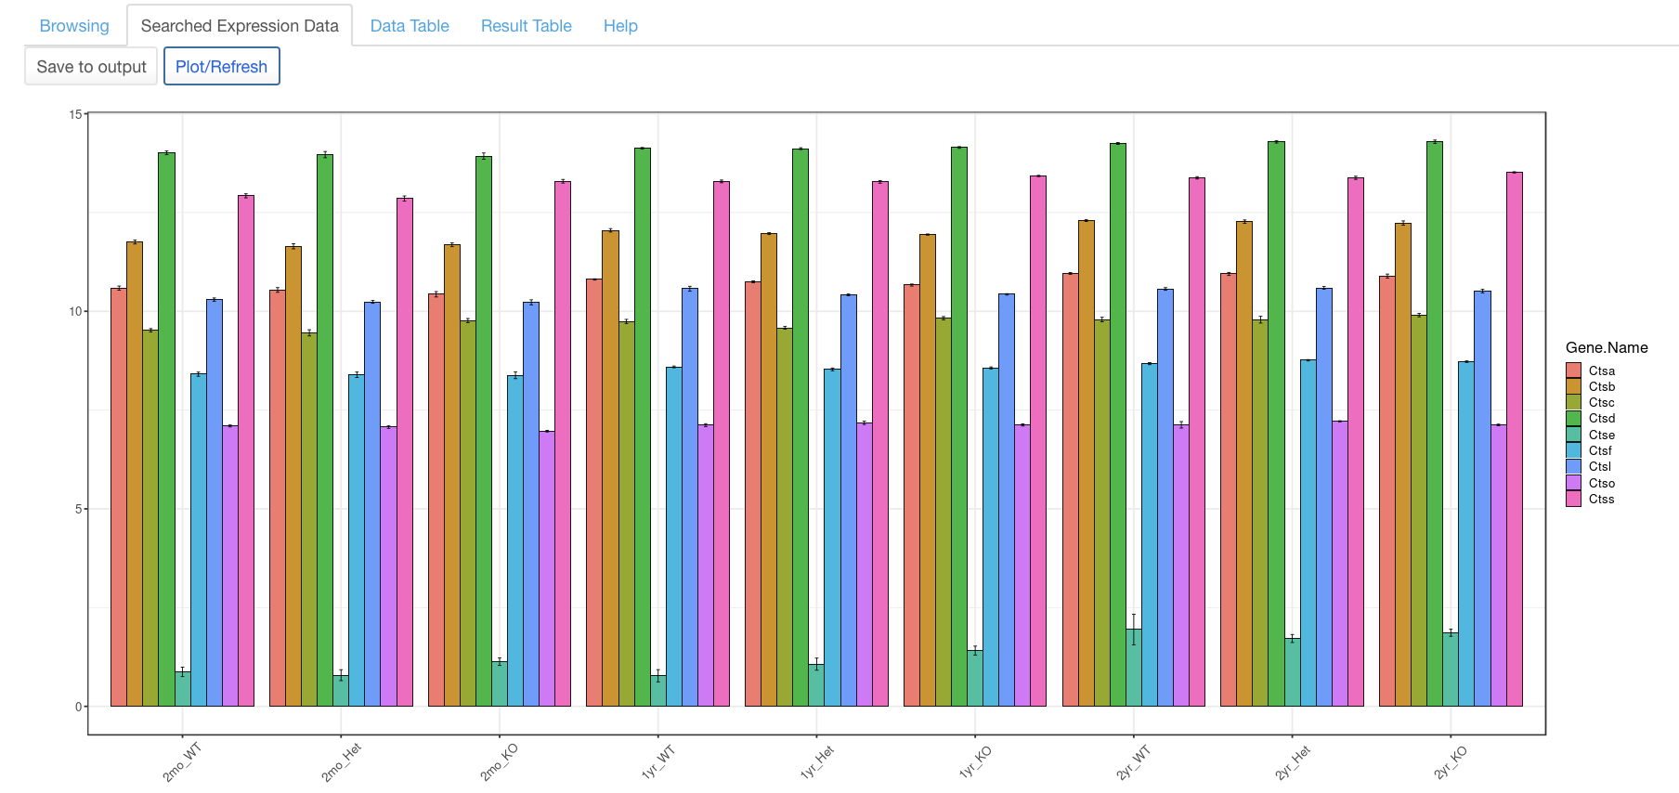

## Data Table

This tab is specifically designed to search protein expression values in proteome datasets. For a demo of this feature, we select a proteome dataset from Connor-Robson et al., 2019. 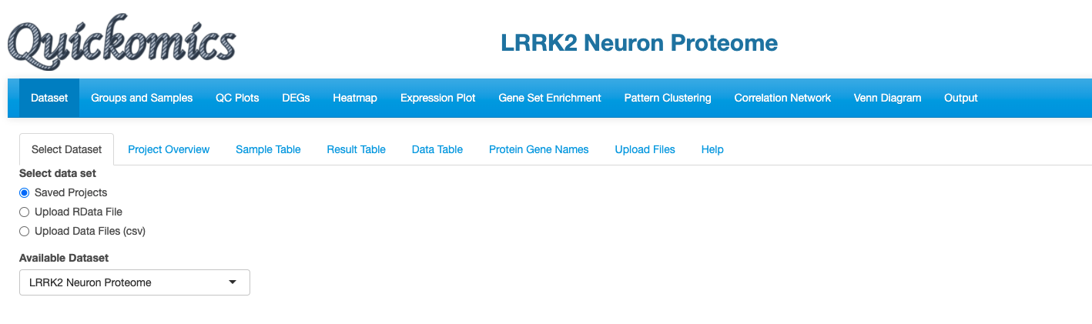

**Dataset name**

**1.Select Proteome dataset**

Once the dataset is selected, we go into the “Searched Expression Data” tab to select a geneset.

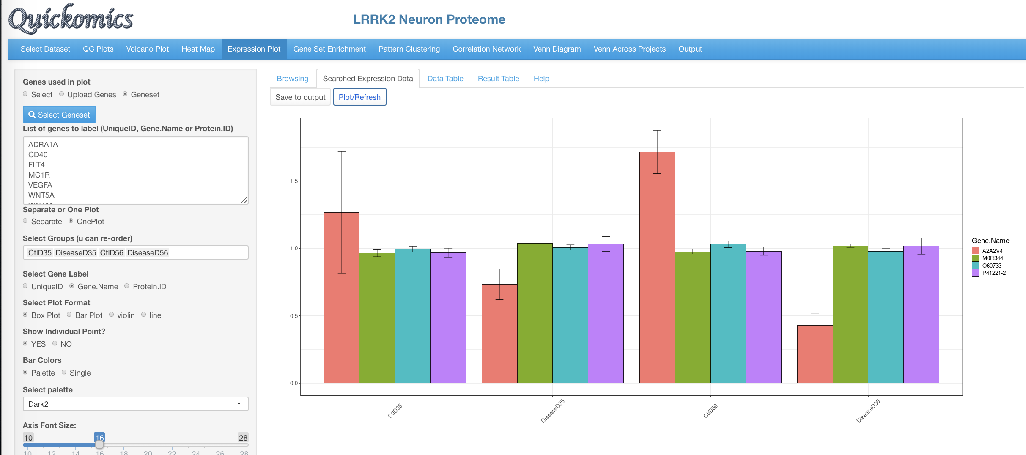 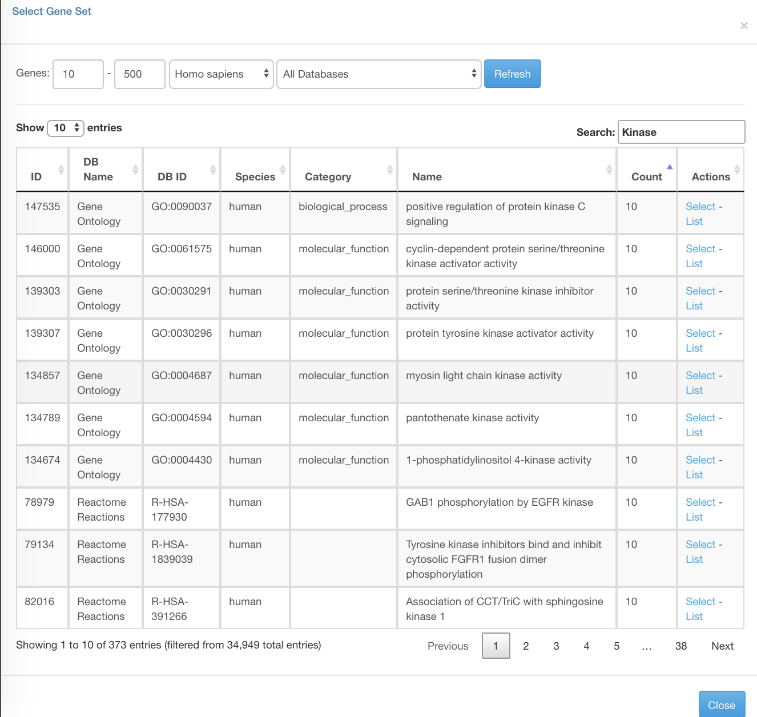

**5. Click Plot/Refresh**

**4. Select list**

**3. Search kinase**

**2. Select Geneset**

**1.Click on Selected Expression Data**

Finally, we click the “Data Table” tab to look at the expression of the protein selected for a searchable table of values.

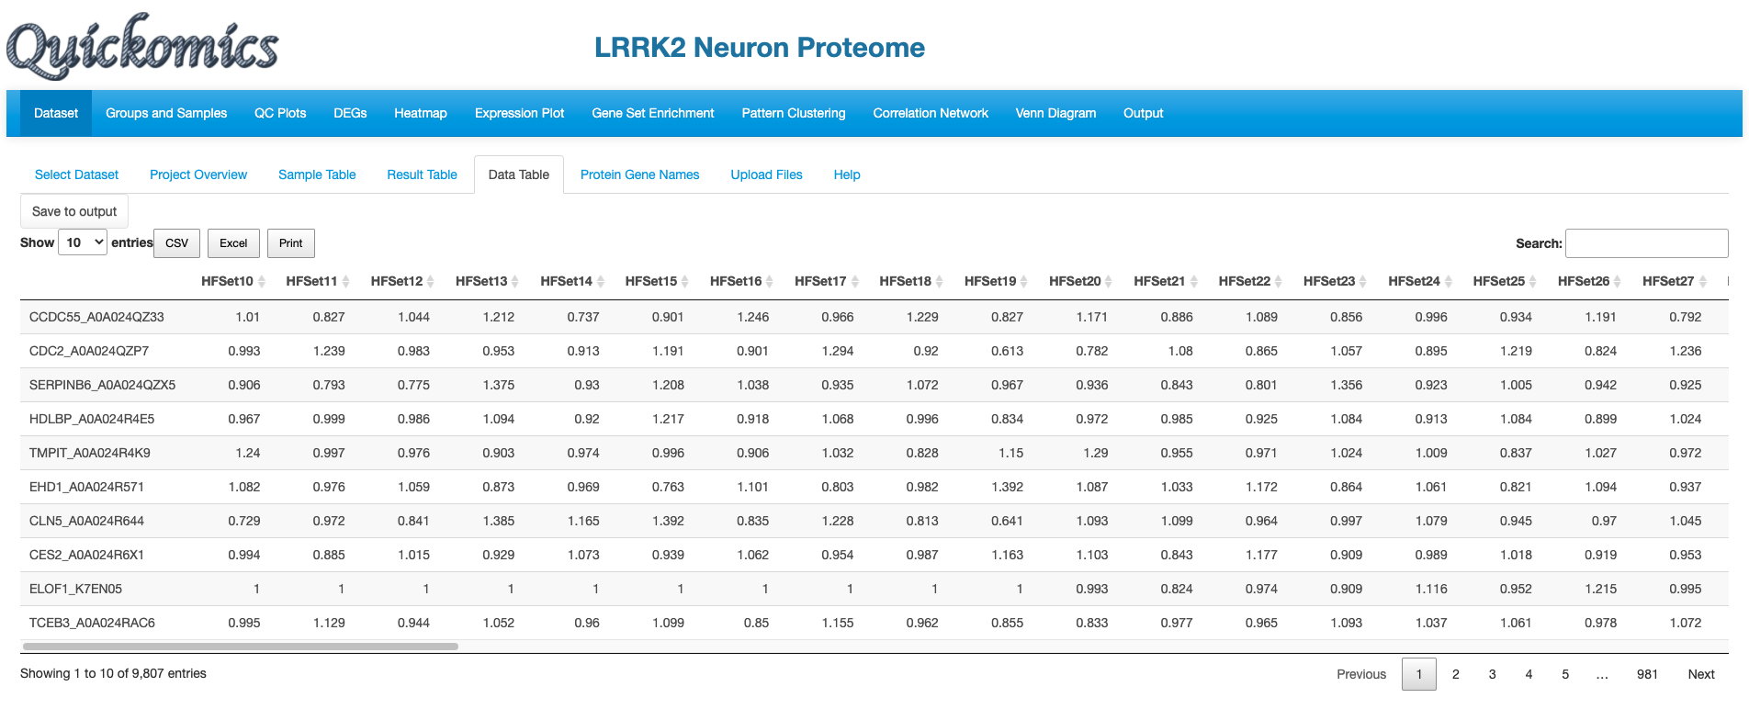

**Protein expression values**

## Result Table

This tab lists the log FC of the genes selected in “Selected Expression Data” as a searchable table. Each comparison defined is probed for the genes in the list and the P value and Fold changes are listed. This is specifically designed for the gene values, unlike “Data Table” in the previous section (6.3) that is designed for protein values.

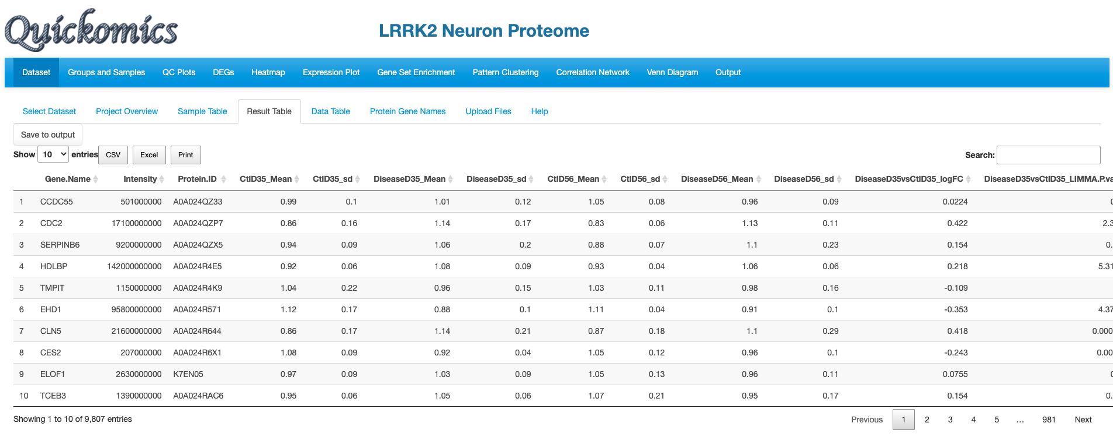

**Steep gradient indicating that last few genes have different expression and abundances**

**Differential gene exp values**

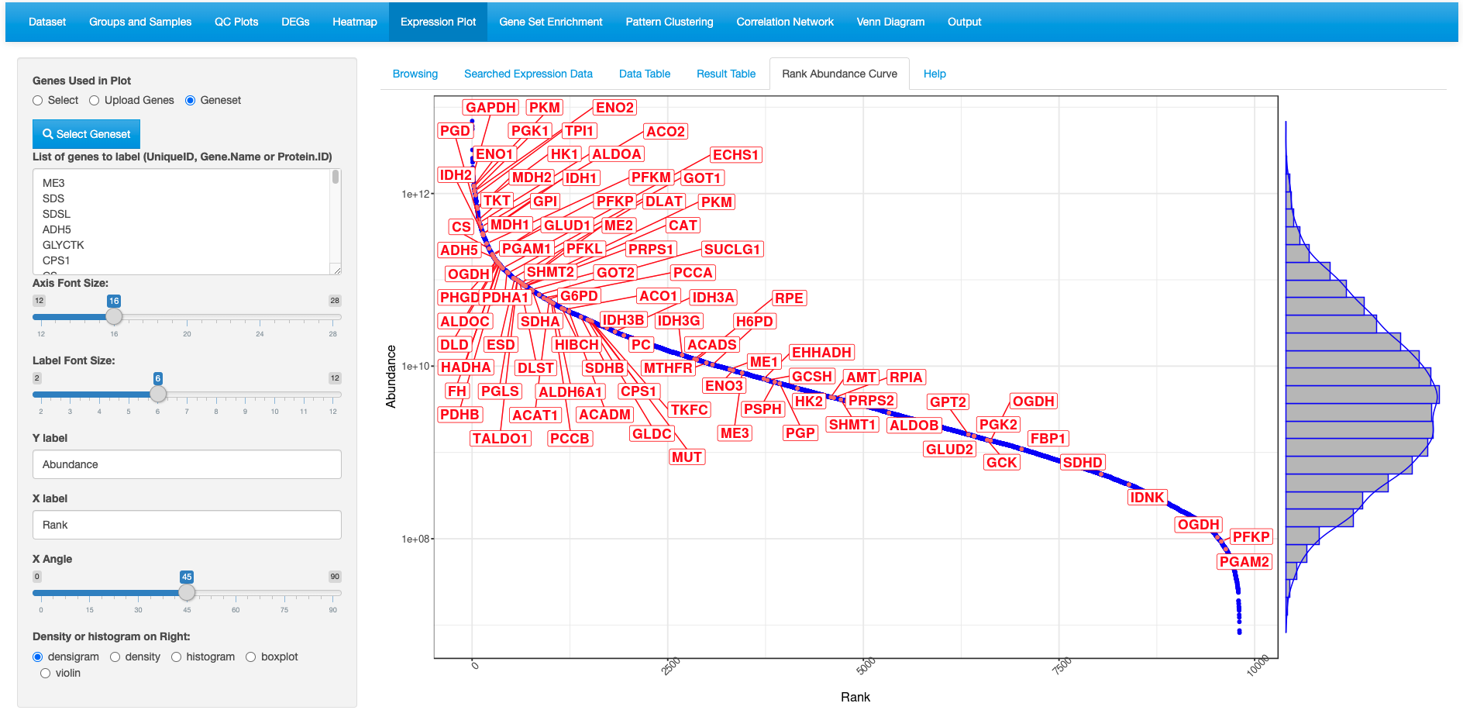

**Shallow gradient indicating that those genes have similar expression and abundances**

**2. Adjust plotting settings**

**1. Select genes to display**

# Gene Set Enrichment

This functionality in Quickomics is an extension to the differential gene identification. Users are able to use different cutoffs to filter out DEGs in different comparisons and probe pathways enriched. This is a useful way to make biological sense from the data.

## Gene Set Enrichment

This first tab lets the users pick a particular comparison, apply different cutoff criteria and select from a list of different databases for enrichment analysis. To demonstrate usage of this functionality, we will use the Mouse Microglia RNA dataset. Very similar to the results of the Gyoneva et al., 2019, this analysis points to immune related terms being enriched in the down-regulated genes for 2mon_KOvs2mon_WT.

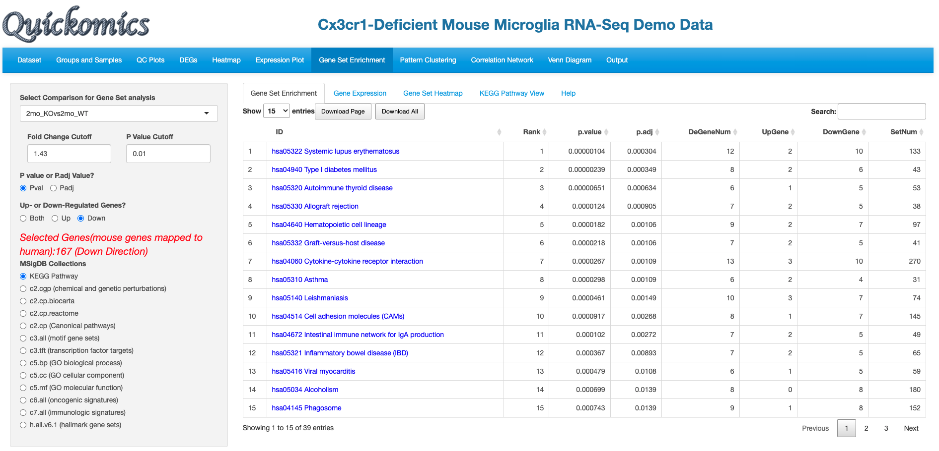

**1.Select comparison**

**2.Select cutoff**

**3.Select Down regulated genes**

**4.Select database**

**Pathways identified sorted by rank**

**Top down regulated pathways are immune related**

Similarly, we pull out the GO enrichment for up-regulated genes.

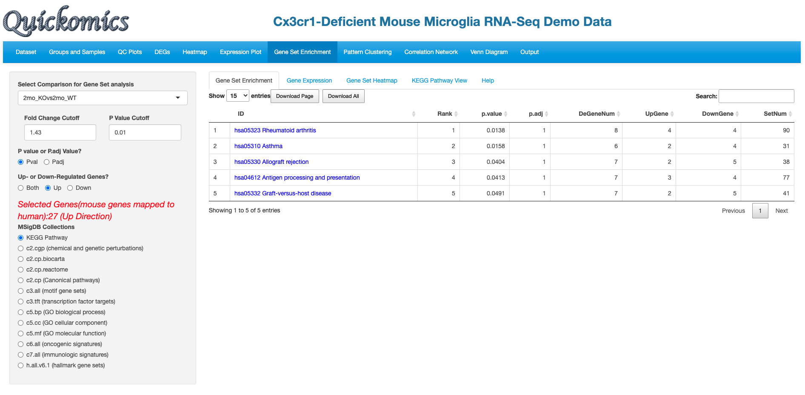

**Select Up regulated genes**

**Fewer Up regulated pathway**

## Gene Expression

For the enriched terms identified in the previous tab (Gene Set Enrichment, section 7.1), Users have the ability to look at the differential values of the genes present in the set. Here we are probing the GO_IMMUNE_RESPONSE identified in the down-regulated category.

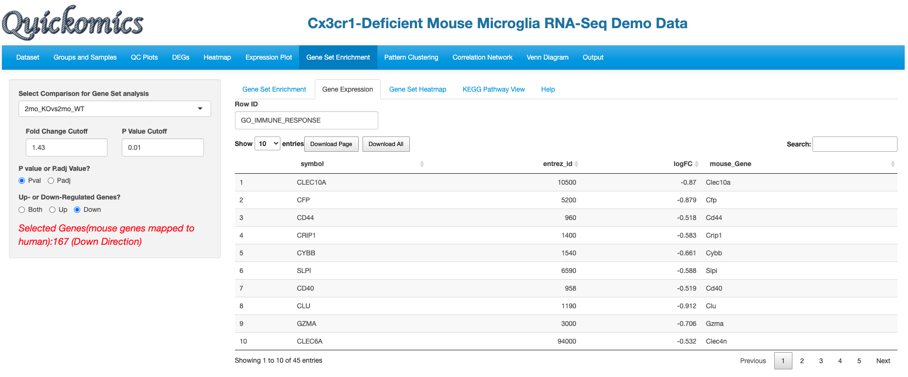

**Differential values of genes**

**Term being probed**

**Select comparison**

## Gene Set Heat Map

Like the “Gene Expression” tab, Users have the ability to plot expression of the genes in the pathway term selected as a heatmap.

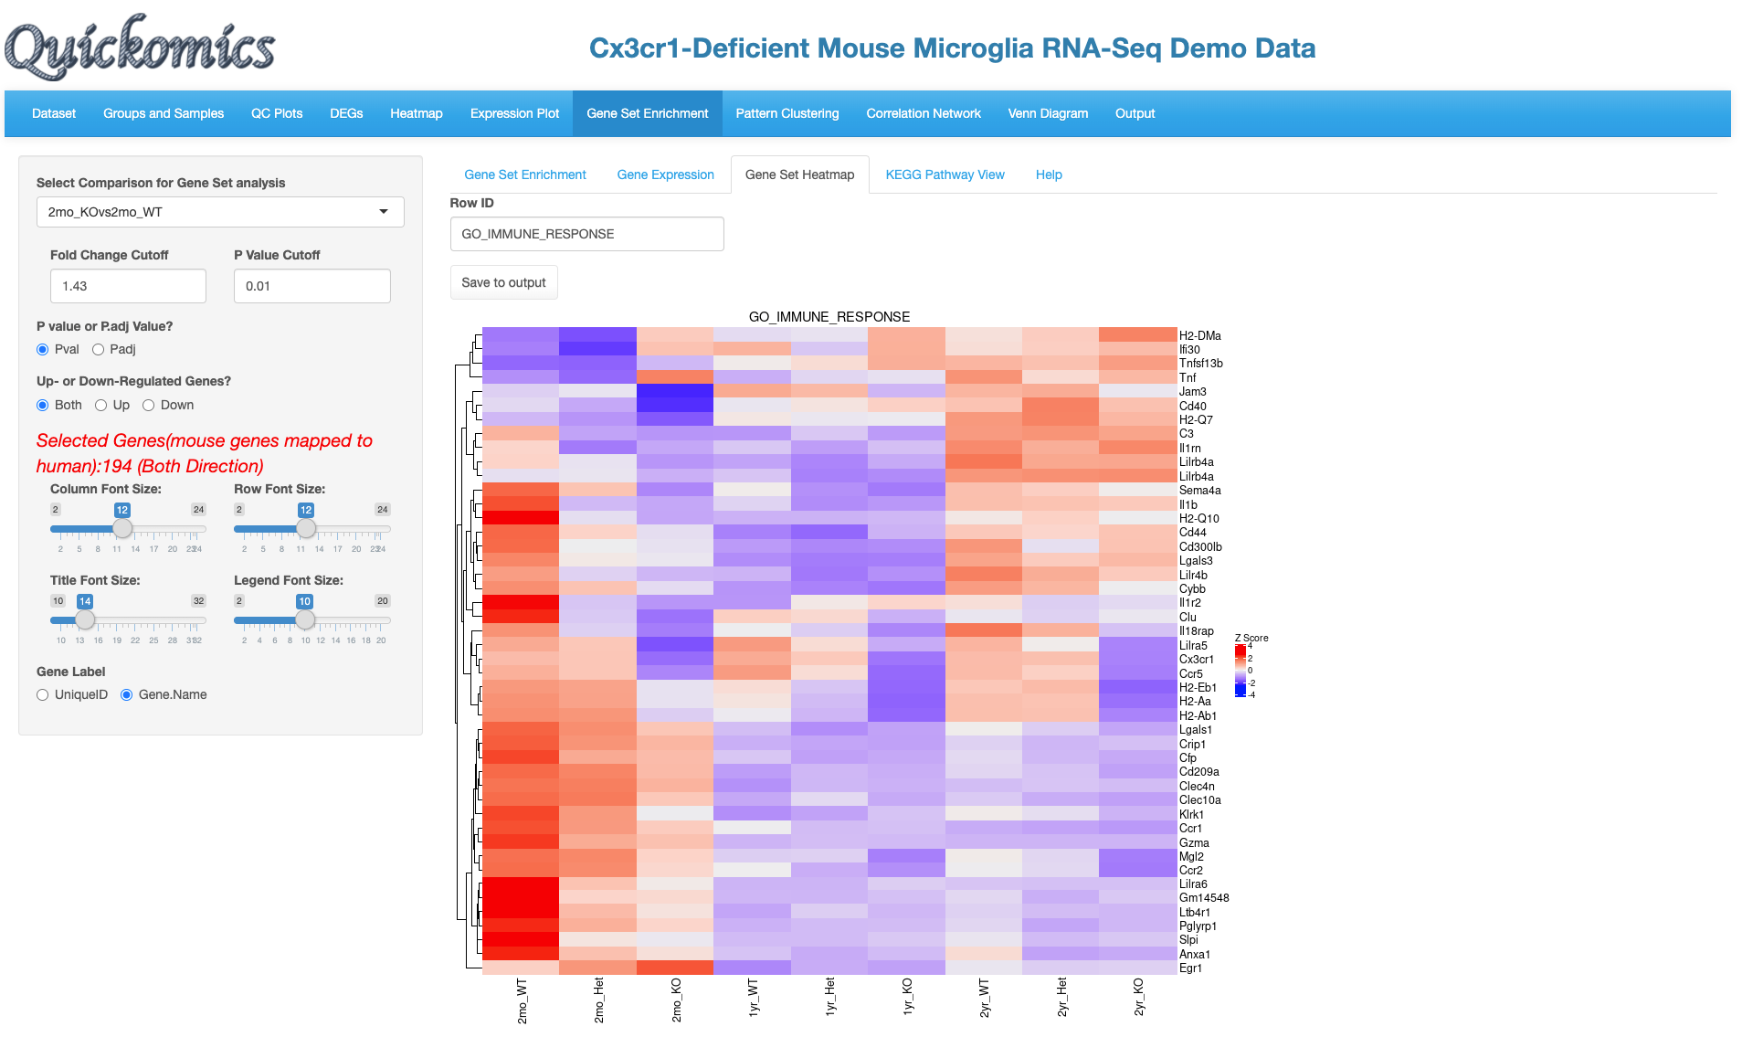

**Differential genes in the pathway**

**Term being probed**

**Select comparison**

## KEGG Pathway View

This functionality is available only to KEGG pathway terms. Users have the option to view the Fold Change levels of different genes in the KEGG pathway selected for up to 5 comparisons. In this example we demo the KEGG pathway “hsa04612 Antigen processing and presentation” as identified as a down-regulated term in the 2mon_KOvs2mon_WT and 1yr_KOvs1yr_WT comparisons.

This figure identifies all the genes that are differentially expressed in this pathway. It is also clear that genes in the MHC I pathway don’t change, but many genes in the MHC II pathway are down regulated in both the comparisons.

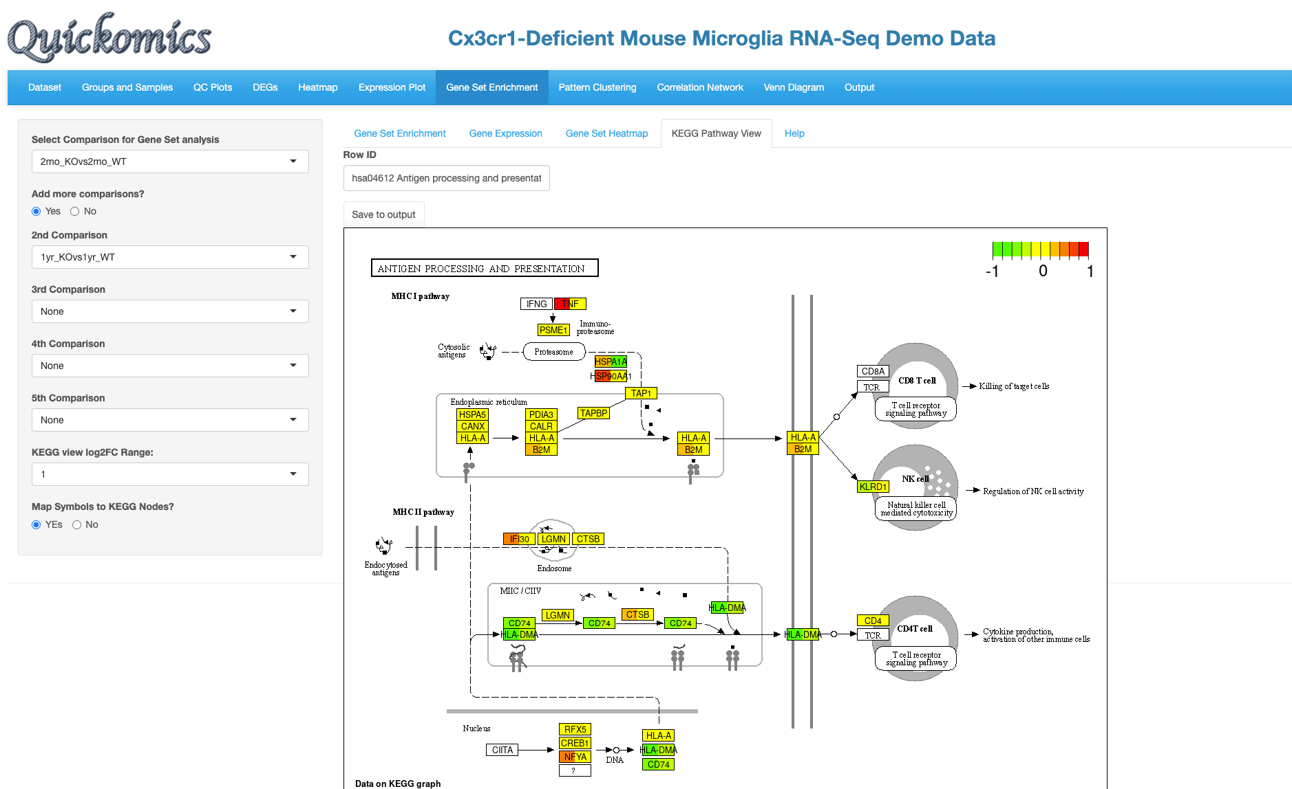

**1.Select comparison #1**

**2.Select comparison #2**

**3.Select more comparisons if needed**

**4.Select logFC range**

**MHC II genes changed in both comparisons selected**

**MHC I genes not changed much**

# Pattern Clustering

This functionality in Quickomics helps cluster genes based on their expression profiles across different groups. There are 3 different methods of clustering the genes: soft (fuzzy) clustering, k-means and partitioning around medoids (PAM).

## Clustering of Centroid Profiles

Users have the ability to either select the DEGs identified before as the list of genes to cluster based off on or upload a custom gene list. DEGs are selected based off all the comparisons, and cutoffs can be applied to limit the number of genes. In this example below, we use the top DEGs with a Fold Change cutoff of 3 to identify 6 clusters of genes.

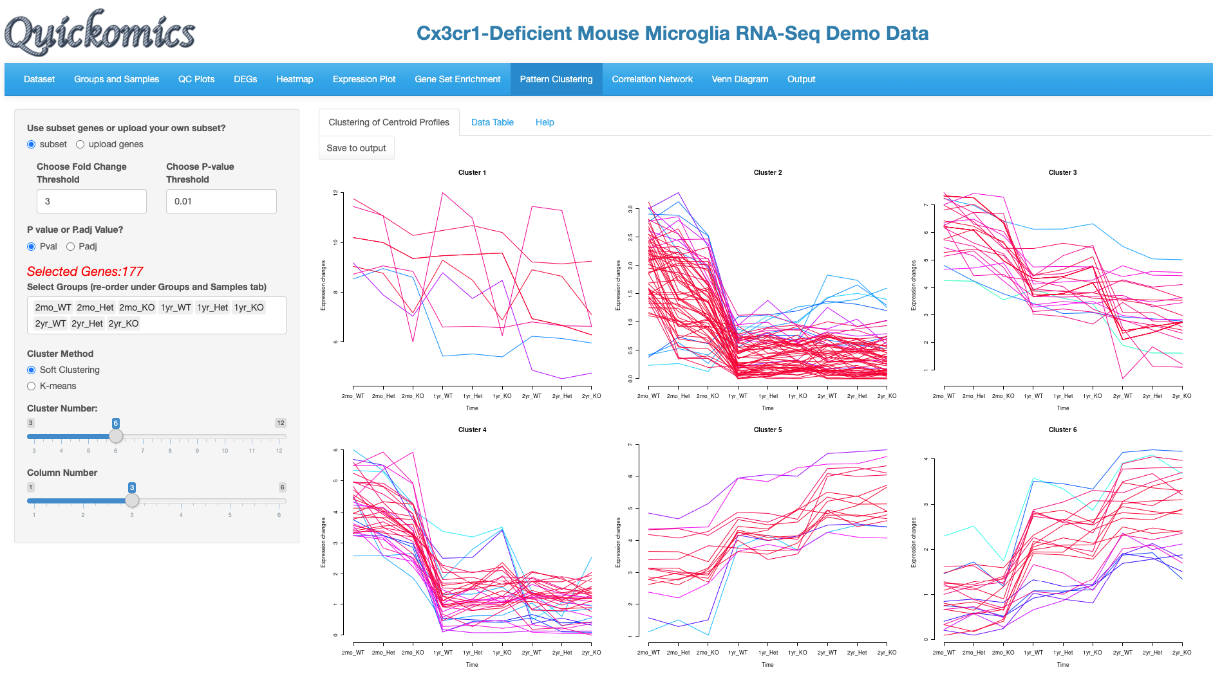

**Genes are clustered into 6 groups**

**2.Select cutoffs**

**1.Select genes**

**3.Select clustering method**

Please note that this visualization for this dataset is novel and was not previously reported in Gyoneva et al., 2019. The genes in each cluster can be viewed in the “Data Table” tab.

## Data Table

The clusters and genes identified in the previous tab can be probed in this tab.

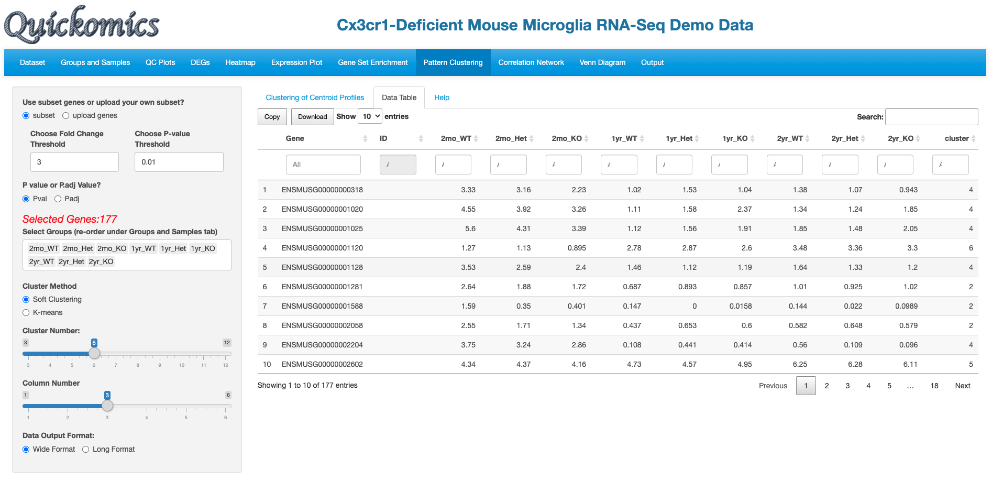

**Cluster numbers as seen in previous tab**

# Correlation Network

This module helps build co-expression networks based on protein-protein correlation. Users have the ability to enter 1 or more genes to identify if their expression is correlated.

## visNetwork

This uses the R package visNetwork (ADD REFERENCE) to calculate expression correlation of genes and build the visualization. Users have the ability to choose the R cutoff for the correlation statistics. In this example below, we probe 3 genes and identify the expression of other genes that are correlated with them.

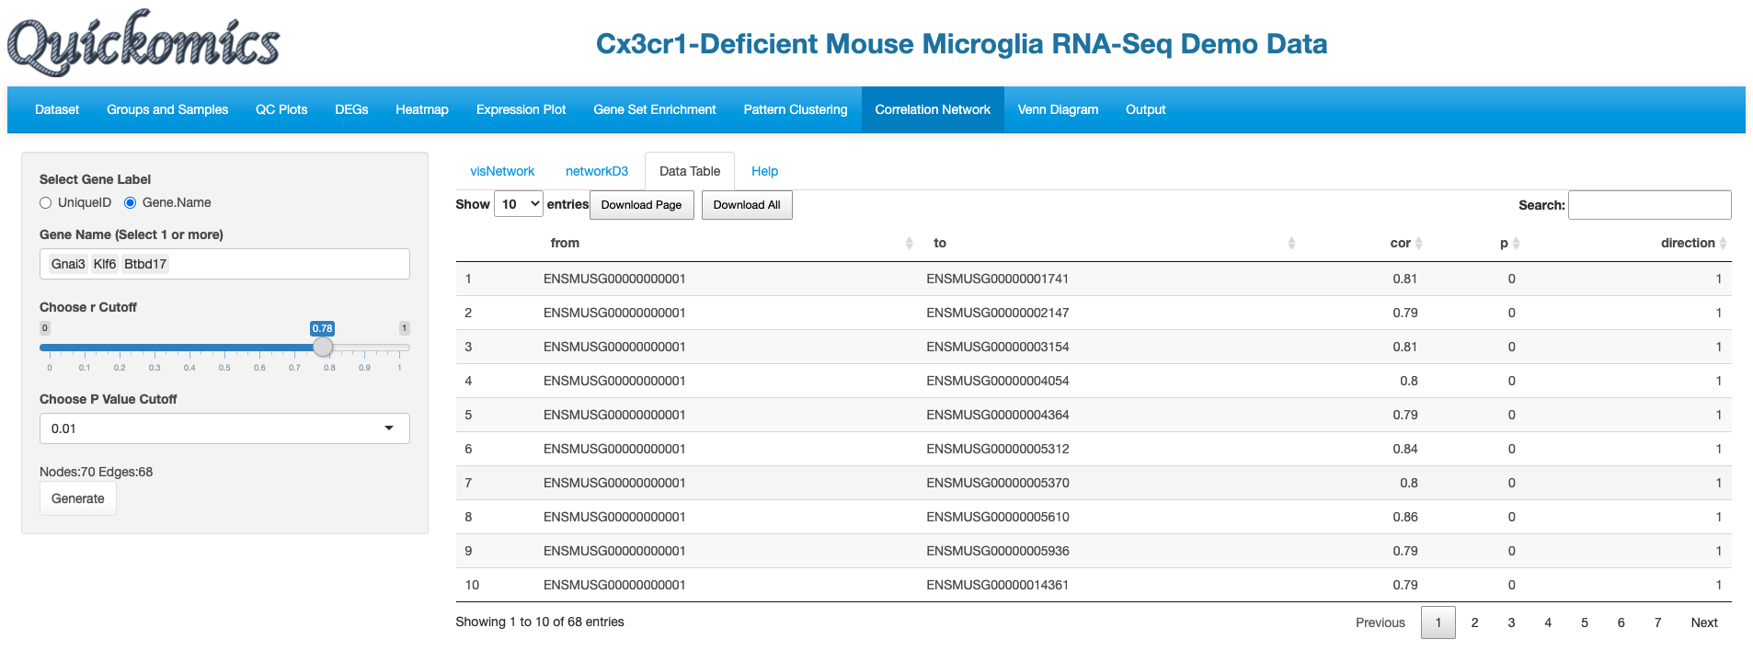

**Genes identified as correlated**

**Gene queried**

The following network plot was produced. Gnai3 is part of a large network with multiple genes correlated with it. On the other hand, Klf6 was correlated with 2 other genes, while Btbd17 was not correlated with any genes.

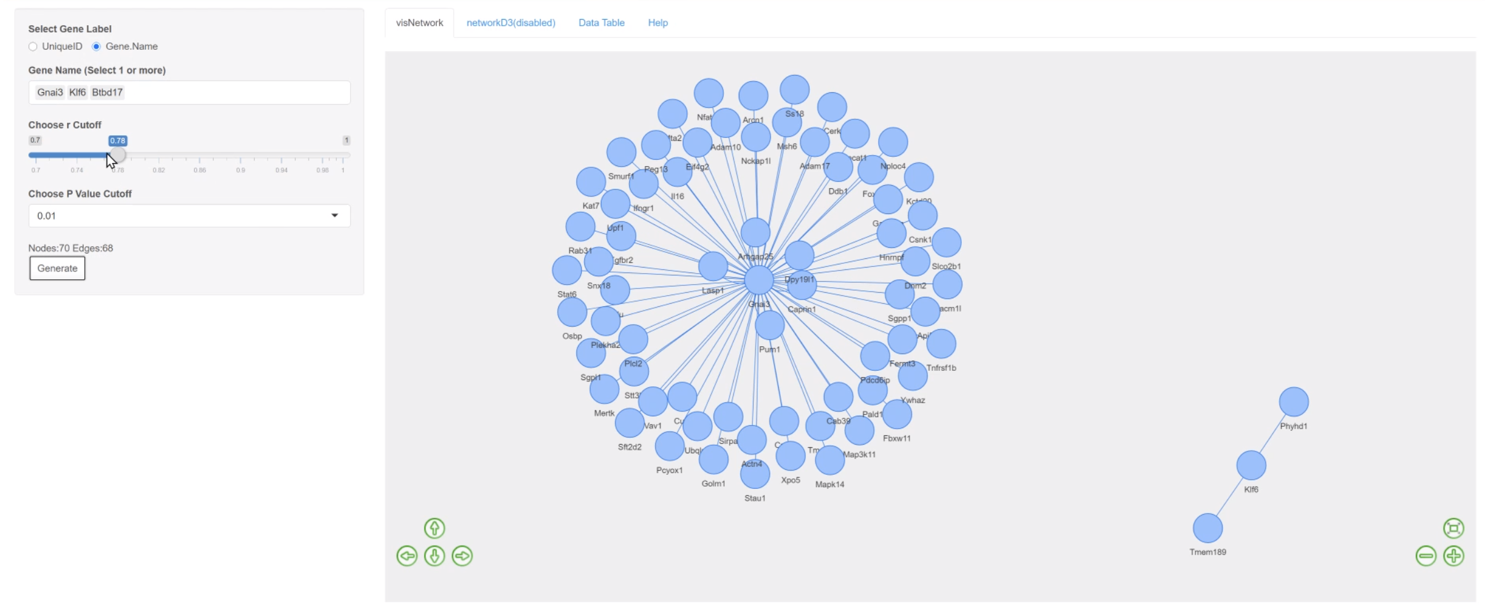

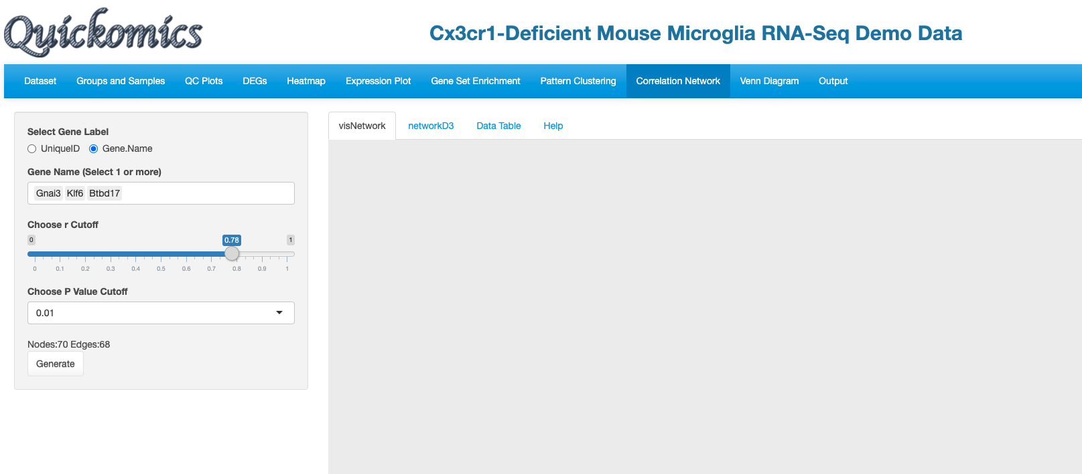

**3. Hit generate**

**2. Select cutoffs**

**1. Select genes**

## Data Table

The genes identified in the previous tab as part of the network plot are available as a table in this tab. Users can perform searches and sort based on correlation statistics.

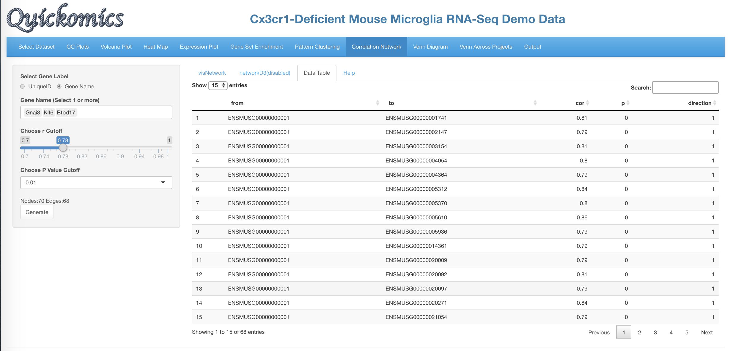

**Genes identified as correlated**

**Gene queried**

# Venn Diagram

This module in Quickomics lets users identify DEGs common or unique to different comparisons within one project. Users have the option to either visualize these DEGs as a highly customisable Venn Diagram or download a table with the gene names.

## vennDiagram

To view the DEGs as a Venn Diagram, Users have the option to see the intersection of DEGs for upto 5 different comparisons. They can also use all DEGs or just the ones that are Up or Down regulated.

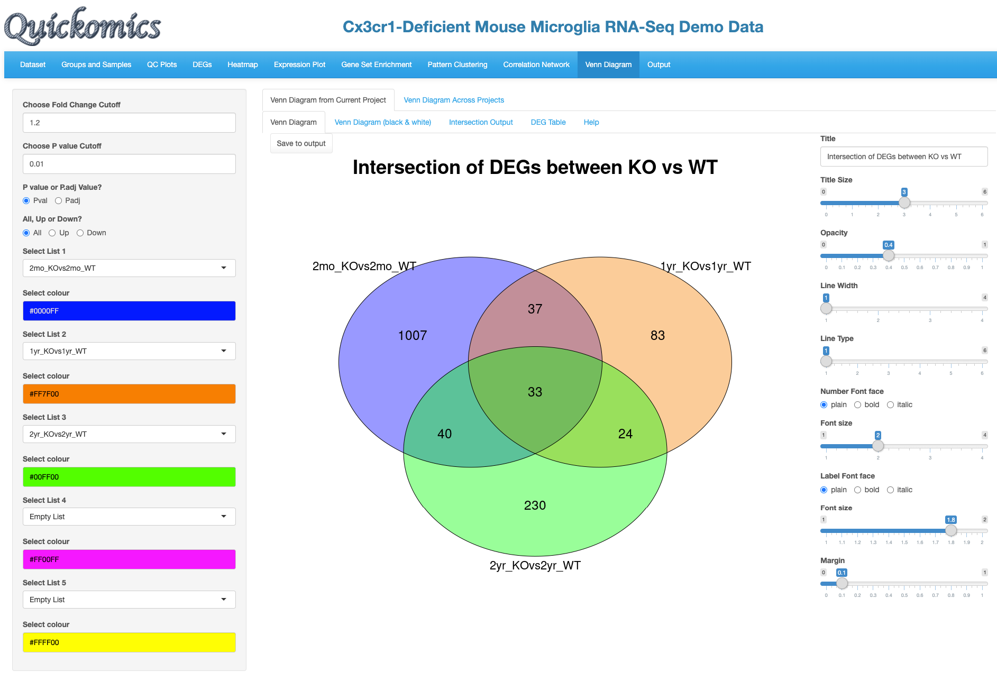

**1.Select cutoffs**

**2.Select DEG category**

**3.Select up to 5 comparison**

**Resulting Venn Diagram can be customized**

In this example there were 33 DEGs that were identified in the three comparisons probed here.

## VennDiagram(black & white)

This tab has the same plot seen before in Section 10.1 vennDiagram but highly simplified and in black and white.

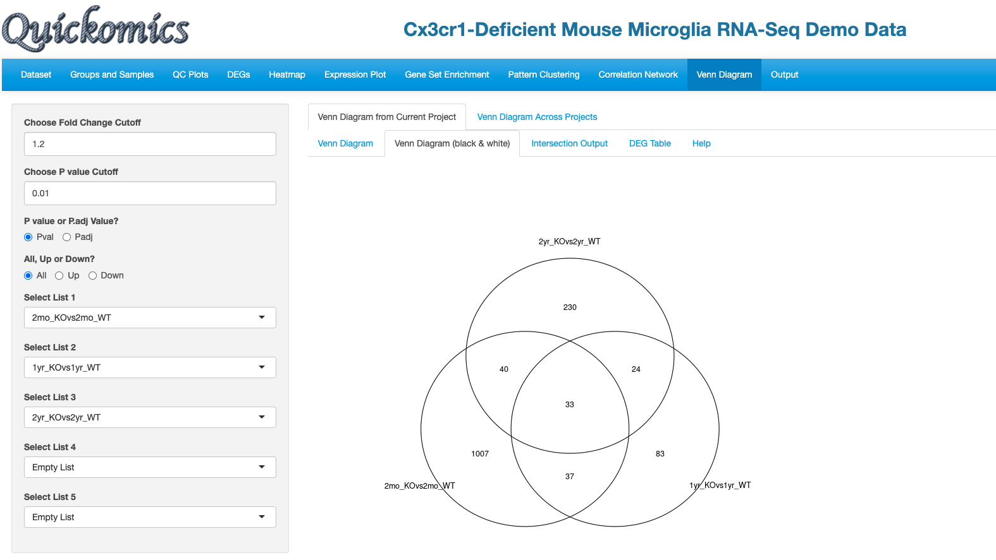

**No customization available**

**Same input as before**

## Intersection Output

This tab lets the User view the individual genes that were present in the Venn Diagram and the distribution of the genes in intersection regions.

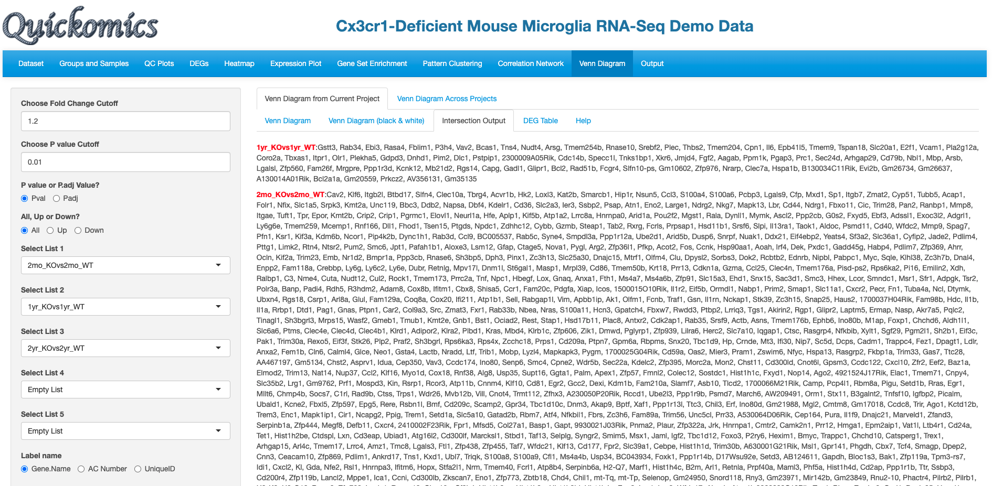

**Genes present only in sample 2**

**Genes present only in sample 1**

## 

## DEG Table

This tab lets the Users view the Fold Change and Pvalue of the genes identified in the Venn Diagram in the comparisons being queried.

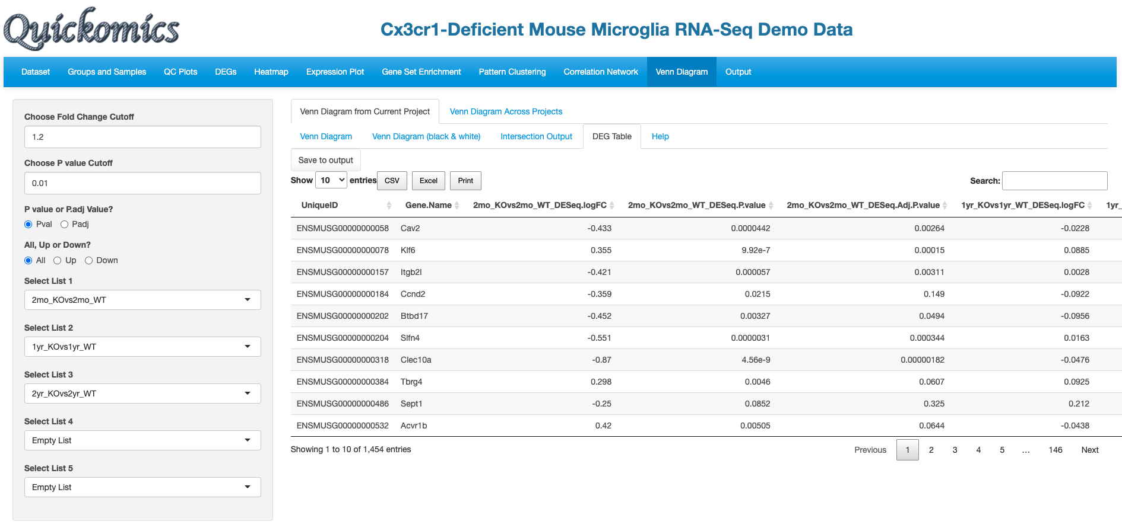

**Fold Change and p value statistics in each comparison**

# Venn Across Projects

This functionality in Quickomics is the only one that lets users probe more than one project/dataset together. The DEGs identified in different comparisons across projects/datasets loaded in the interface can be compared here. Some good use cases are for identifying common DEGs present in RNAseq vs Mass-spec Proteomics of the same samples.

## vennDiagram

To illustrate this feature, we compare the two RNAseq and two Proteomic comparisons from Connor-Robson et al., 2019. We load 2 comparisons from each dataset/project and view the number of DEGs that are common and different between the 4 comparisons.

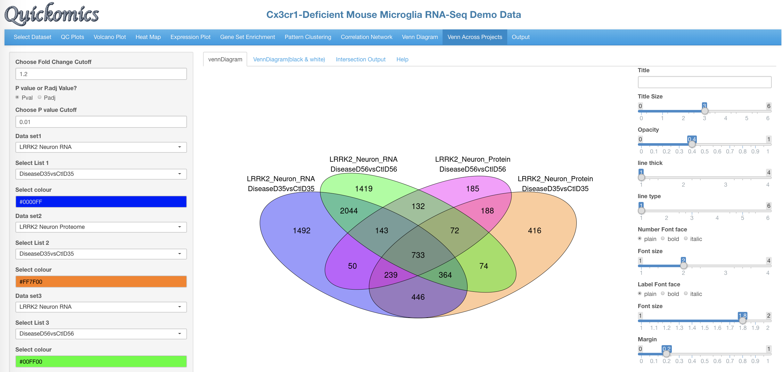

**Resulting Venn Diagram can be customized**

**3.Select upto 5 projects and comparison**

**2.Select DEG category**

**1.Select cutoffs**

Users have the option to view this Venn Diagram as a Black & White plot.

## Intersection Output

Like in 10.3 Intersection Output, Users can view the individual genes present in different regions of the Venn Diagram, like the ones identified in all the samples, or the ones only present in 3 of them.

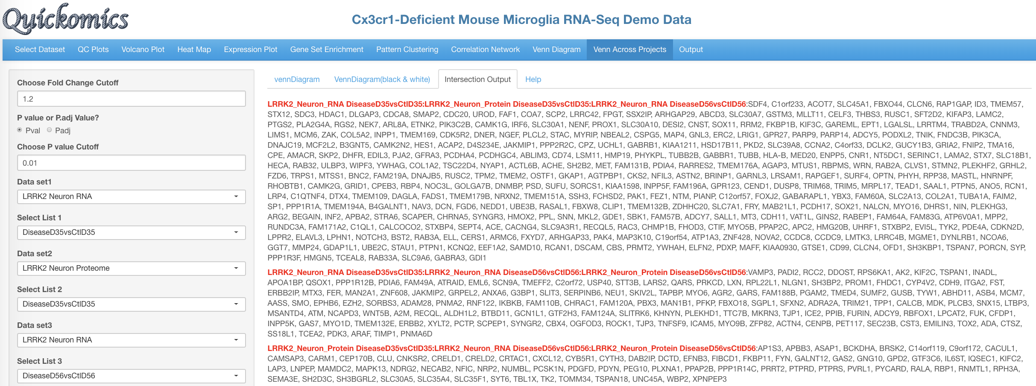

**Genes present only in 3 of the samples**

# Output

This final tab in Quickomics is available for users to download plots in high resolution, including for use in publications. Users can save different plots by clicking on “Save to Output” present on the top left corner of the plot during analysis and exploration of the datasets in all previous tabs. Upon clicking on the “Output” tab as seen in the image below, Users can see a list of plots that are available to download to their local machine.

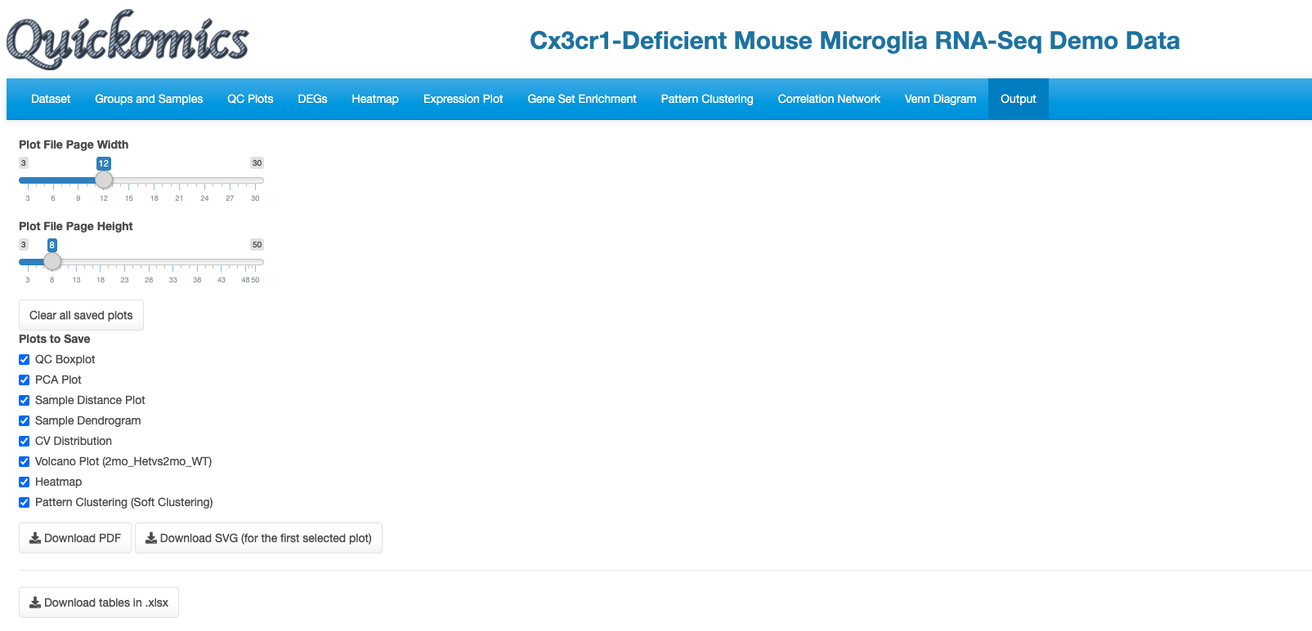

**Plots can be downloaded as PDF or SVG**

**Select all the plots available to save**

**Select width and height of plots to save**